
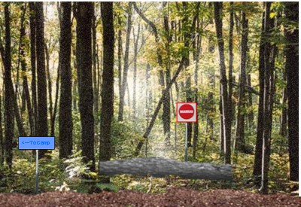
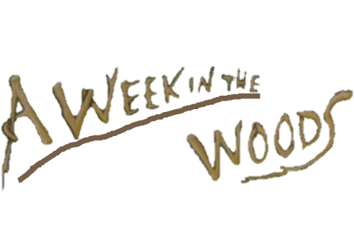
When in the woods:
A tree over a path means, the path is closed. This is dangerous because you don’t know what dangers lie ahead.
?
By Andrew Clements

