Antigone People Matching

- The current ruler of Thebes; cause of trouble in the play
- Haemon’s mother and Creon’s wife; kills herself at the end of the story
- The protagonist of the story; believes it is the god’s will that Polynices should be buried
- The former ruler of the city; killed his father and married his mother.
- Refuesd to give up the throne; defended Thebes; buried with full military honor
- Antigone’s sister; a chicken
- Creon’s son; makes a prediction of more deaths
- The author of the story.
- Blind profit; causes Creon to change his mind
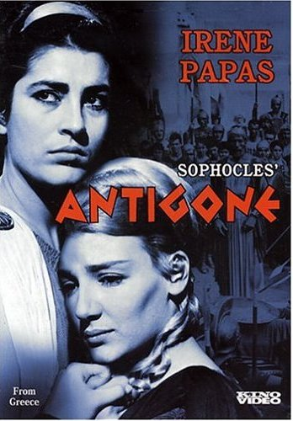
- Fought against Thebes; not to be buried
- Antigone
- Sophocles
- Oedipus
- Eteocles
- Polynices
- Ismene
- Creon
- Haemon
- Tiresias
- Eurydice

