Michael Plasmeier
7/28/2026
P.D.:3

The Physics of a Baseball

Baseballs are made specifically for the game of Baseball. The way the ball bounces, the way the ball flies though the air, and the way it flies, all are parts of baseball. In fact, the game and game strategies all take in consideration how baseballs fly. The pitcher throws the ball in a certain way to make the ball fly over the plate, but very hard to hit. Generally the core of a baseball is cork, rubber, or a mixture of the two. Around the core are various materials including yarn and twine, or sometimes wool. A leather cover is put on, in two pieces, and stitched together using 104 stitches of waxed red cotton thread. (http://en.wikipedia.org/wiki/Baseball_%28object%29).
Richard Fitzpatrick from the Physics Department at the University of Texas at Austin has a page on the physics of baseball pitching at http://farside.ph.utexas.edu/teaching/329/lectures/node69.html. He says that a baseball in flight is subject to three distinct forces. These are, gravity, which causes the ball to accelerate vertically downwards. This force is all around us and can not be avoided. The second force is air drag, which impedes the ball's motion through the air. This can be affected by the smoothness of the ball. The third force is called the Magnus force, which permits the ball to curve laterally. This is caused by the ball spinning through the air. The pitcher has direct control on how the ball spins. However, he can not really affect the smoothness of the ball, or can not at all affect the force of gravity on the ball. He can also alter the force at which he throws it. In fact, the different type of pitches, make the ball spin in different ways. He is a diagram of how the ball spins from the above website:
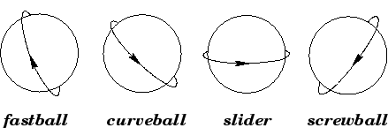

A curveball is thrown by having the pitcher makes a finger-snapping, wrist twisting movement as the ball is released. This creates a top spin, so that the top of the ball is moving forward against the air, while the lower half is spinning backward and moving the same direction as the air. (http://wings.avkids.com/Book/Sports/advanced/curveball-01.html) The aerodynamics of a baseball can also be summed up like this:
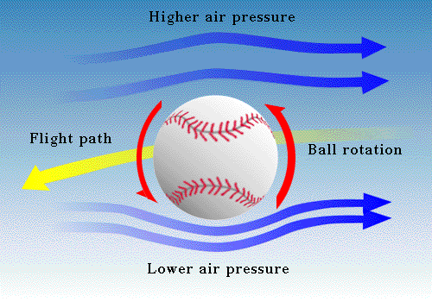

http://faculty.tcc.fl.edu/scma/carrj/Java/baseball4.html is a very good simulation of hitting a baseball and how it flies. Also, there is research about if a corked bat will improve how you hit it. Aluminum bats also make the ball easier to hit. Alan M. Nathan from the Department of Physics at the University of Illinois at Urbana-Champaign said in the document http://www.npl.uiuc.edu/~a-nathan/pob/corked-bat-remarks.doc that the use of a corked bat has no affect on a long fly ball. However, the corked bat is lighter, allowing a contact-type hitter to hit the ball easier by being able to maneuver the bat easier. Aluminum bats increase the sweet spot of the bat, and make it much easier to hit an inside pitch.

Also, work is being done to reduce injuries from baseball in Little-Leagues across the country. These balls are softer and lighter. A study by the National Institute for Sports Science and Safety at http://www.nisss.org/balltest.htm, finds that the stiffer the ball, the greater the impact force. This means that if you make a ball lighter, it will hit softer. This causes fewer injuries in young players.

Baseball is all about physics. That is why pitchers and batters need to know about physics and aerodynamics. The way the ball is thrown, the way it is hit and the type of bat and balls used all have an effect on the game. Corked bats and aluminum bats change the way the bat can be hit. Special balls are used to reduce injury to little kids.

Most of these sites linked from http://www.npl.uiuc.edu/~a-nathan/pob/index.html

