Michael Plasmeier 7/28/2026
National Wildlife
Living On the Fringe - Apr/May ‘99

Is there a bobcat in your neighborhood? Well, if you live near San Francisco, Yes. If not, you might. Bobcats live in almost every U. S. state and Canada province.
They happen to live right next to a human backyard.
In San Francisco, a study is being done. The bobcats will go right up to the developments of houses. They only live on the edge; they don’t go in past the first row of houses. The bobcats don’t like to cross streets or cross grass. Bobcats will go the long way around in order to go through brush. A bobcat in Los Angeles lives on a ledge above a highway interchange. In the woods, a bobcat was walking a long a path till humans came up the path. The bobcat simply walked 10 yards off the trail, and waited for the humans to pass. Another animal might have just ran away.
Bobcats will eat almost any small to medium size animal. The eat rabbits and voles, which are small mice. The can even kill a deer that is 4 to 5 times its own weight. A bobcat only weights about 20 pounds. The things that eat it are mostly wolves and bears. The numbers of these predators are going down, letting the numbers of bobcats increase. A survey shows that there are about 700,000 to 1.5 million in the USA. This number is believe to be more then in the colonial days.
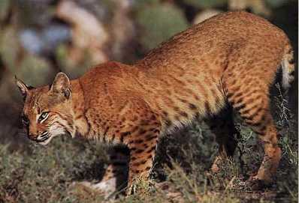
Bobcats live very close to humans. They are also amazing creatures with their ability to live anywhere.

