Bridge Basics
Because of the wide range of structural possibilities, this Spotter's Guide shows only the most common fixed (non-movable) bridge types. Other types are listed in the Bridge Terminology page. The drawings are not to scale. Additional related info is found on the other Terminology pages which are linked to the left.
The four main factors are used in describing a bridge. By combining these terms one may give a general description of most bridge types.
- span (simple, continuous, cantilever),
- material (stone, concrete, metal, etc.),
- placement of the travel surface in relation to the structure (deck, pony, through),
- form (beam, arch, truss, etc.).
The three basic types of spans are shown below. Any of these spans may be constructed using beams, girders or trusses. Arch bridges are either simple or continuous (hinged). A cantilever bridge may also include a suspended span.
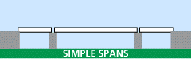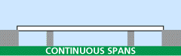
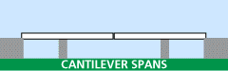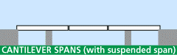
Examples of the three common travel surface configurations are shown in the Truss type drawings below. In a Deck configuration, traffic travels on top of the main structure; in a Pony configuration, traffic travels between parallel superstructures which are not cross-braced at the top; in a Through configuration, traffic travels through the superstructure (usually a truss) which is cross-braced above and below the traffic.
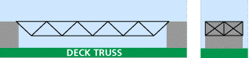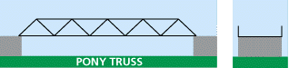
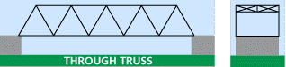

Beam and Girder types
Simple deck beam bridges are usually metal or reinforced concrete. Other beam and girder types are constructed of metal. The end section of the two deck configuration shows the cross-bracing commonly used between beams. The pony end section shows knee braces which prevent deflection where the girders and deck meet.
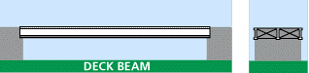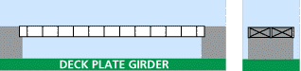
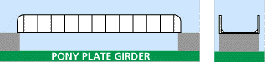
One method of increasing a girder's load capacity while minimizing its web depth is to add haunches at the supported ends. Usually the center section is a standard shape with parallel flanges; curved or angled flanged ends are riveted or bolted using splice plates. Because of the restrictions incurred in transporting large beams to the construction site, shorter, more manageable lengths are often joined on-site using splice plates.
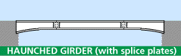
Many modern bridges use new designs developed using computer stress analysis. The rigid frame type has superstructure and substructure which are integrated. Commonly, the legs or the intersection of the leg and deck are a single piece which is riveted to other sections.
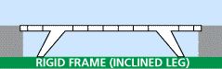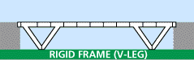
Orthotropic beams are modular shapes which resist stress in multiple directions at once. They vary in cross-section and may be open or closed shapes.
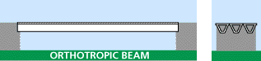

Arch types
There are several ways to classify arch bridges. The placement of the deck in relation to the superstructure provides the descriptive terms used in all bridges: deck, pony, and through.
Also the type of connections used at the supports and the midpoint of the arch may be used - - counting the number of hinges which allow the structure to respond to varying stresses and loads. A through arch is shown, but this applies to all type of arch bridges.
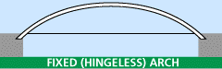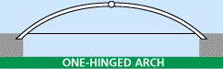
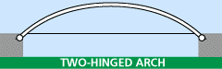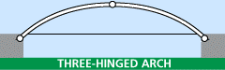
Another method of classification is found in the configuration of the arch. Examples of solid-ribbed, brace-ribbed (trussed arch) and spandrel-braced arches are shown. A solid-ribbed arch is commonly constructed using curved girder sections. A brace-ribbed arch has a curved through truss rising above the deck. A spandrel-braced arch or open spandrel deck arch carries the deck on top of the arch.
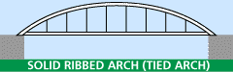
Some metal bridges which appear to be open spandrel deck arch are, in fact, cantilever; these rely on diagonal bracing. A true arch bridge relies on vertical members to transmit the load which is carried by the arch.
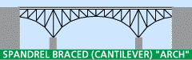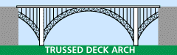
The tied arch (bowstring) type is commonly used for suspension bridges; the arch may be trussed or solid. The trusses which comprise the arch will vary in configuration, but commonly use Pratt or Warren webbing. While a typical arch bridge passes its load to bearings at its abutment; a tied arch resists spreading (drift) at its bearings by using the deck as a tie piece.
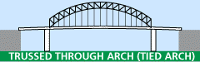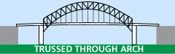
Masonry bridges, constructed in stone and concrete, may have open or closed spandrels A closed spandrel is usually filled with rubble and faced with dressed stone or concrete. Occasionally, reinforced concrete is used in building pony arch types.
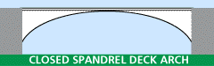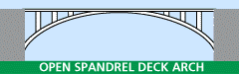

Truss - simple types
A truss is a structure made of many smaller parts. Once constructed of wooden timbers, and later including iron tension members, most truss bridges are built of metal. Types of truss bridges are also identified by the terms deck, pony and through which describe the placement of the travel surface in relation to the superstructure (see drawings above). The king post truss is the simplest type; the queen post truss adds a horizontal top chord to achieve a longer span, but the center panel tends to be less rigid due to its lack of diagonal bracing.
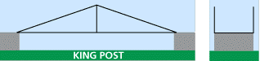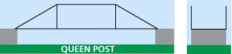

Covered bridge types (truss)
Covered bridges are typically wooden truss structures. The enclosing roof protected the timbers from weathering and extended the life of the bridge.
One of the more common methods used for achieving longer spans was the multiple kingpost truss. A simple, wooden, kingpost truss forms the center and panels are added symmetrically. With the use of iron in bridge construction, the Howe truss - - in its simplest form - - appears to be a type of multiple kingpost truss.
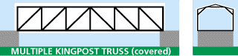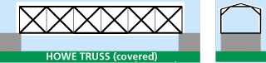
Stephen H. Long (1784-1864) of the U.S. Army Topographical Engineers may be best known for comments he made after one of his missions to explore and map the United States as it expanded westward. In 1819-20, when he viewed the treeless expanse of the Great Plains, he called it the "American Desert" - - and the name stuck. While working for the Baltimore and Ohio Railroad, he developed the X truss in 1830 with further improvements patented in 1835 and 1837. The wooden truss was also known as the Long truss and he is cited as the first American to use mathematical calculations in truss design.
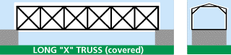
Theodore Burr built a bridge spanning the Hudson River at Waterford, NY in 1804. By adding a arch segments to a multiple kingpost truss, the Burr arch truss was able to attain longer spans. His truss design, patented in 1817, is not a true arch as it relies on the interaction of the arch segments with the truss members to carry the load. There were many of this type in the Pittsburgh area and they continue to be one of the most common type of covered bridges. Many later covered bridge truss types used an added arch based on the success of the Burr truss.
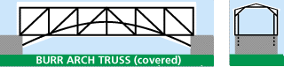
The Town lattice truss was patented in 1820 by Ithiel Town. The lattice is constructed of planks rather than the heavy timbers required in kingpost and queenpost designs. It was easy to construct, if tedious. Reportedly, Mr. Town licensed his design at one dollar per foot - - or two dollars per foot for those found not under license. The second Ft. Wayne railroad bridge over the Allegheny River was an unusual instance of a Town lattice constructed in iron.
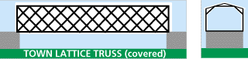
Herman Haupt designed and patented his truss configuration in 1839. He was in engineering management for several railroads including the Pennsylvania Railroad (1848) and drafted as superintendent of military railroads for the Union Army during the Civil War. The Haupt truss concentrates much of its compressive forces through the end panels and onto the abutments.
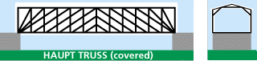
Other bridge designers were busy in the Midwest. An OhioDOT web page cites examples of designs used for some covered bridges in that state. Robert W. Smith of Tipp City, OH, received patents in 1867 and 1869 for his designs. Three variations of the Smith truss are still standing in Ohio covered bridges.
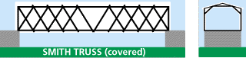
Reuben L. Partridge received a patent for his truss design which is appears to be a modification of the Smith truss. Four of the five Partridge truss bridges near his home in Marysville, Union County, OH, are still in use.
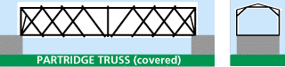
Horace Childs' design of 1846 was a multiple king post with the addition of iron rods. The Childs truss was used exclusively by Ohio bridge builder Everett Sherman after 1883.
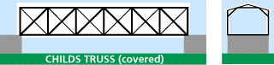

Truss - Pratt variations
The Pratt truss is a very common type, but has many variations. Originally designed by Thomas and Caleb Pratt in 1844, the Pratt truss successfully made the transition from wood designs to metal. The basic identifying features are the diagonal web members which form a V-shape. The center section commonly has crossing diagonal members. Additional counter braces may be used and can make identification more difficult, however the Pratt and its variations are the most common type of all trusses.
Charles H. Parker modified the Pratt truss to create a "camelback" truss having a top chord which does not stay parallel with the bottom chord. This creates a lighter structure without losing strength; there is less dead load at the ends and more strength concentrated in the center. It is somewhat more complicated to build since the web members vary in length from one panel to the next.
When additional smaller members are added to a Pratt truss, the various subdivided types have been given names from the railroad companies which most commonly used each type, although both were developed by engineers of the Pennsylvania Railroad in the 1870s.
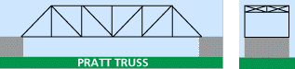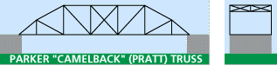
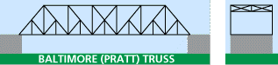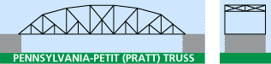
The Whipple truss was developed by Squire Whipple as stronger version of the Pratt truss. Patented in 1847, it was also known as the "Double-intersection Pratt" because the diagonal tension members cross two panels, while those on the Pratt cross one. The Indiana Historical Bureau notes one bridge as being a "Triple Whipple" -- possibly the only one -- built with the thought that if two are better than one, three must be stronger yet.
The Whipple truss was most commonly used in the trapezoidal form -- straight top and bottom chords -- although bowstring Whipple trusses were also built.
The Whipple truss gained immediate popularity with the railroads as it was stronger and more rigid than the Pratt. It was less common for highway use, but a few wrought iron examples survive. They were usually built where the span required was longer than was practical with a Pratt truss.
Further developments of the subdivided variations of the Pratt, including the Pennsylvania and Baltimore trusses, led to the decline of the Whipple truss.
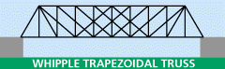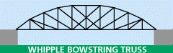

Truss - Warren variations
A Warren truss, patented by James Warren and Willoughby Monzoni of Great Britain in 1848, can be identified by the presence of many equilateral or isoceles triangles formed by the web members which connect the top and bottom chords. These triangles may also be further subdivided. Warren truss may also be found in covered bridge designs.
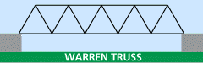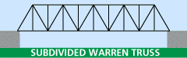
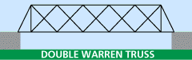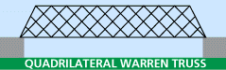

Truss - other types
The other truss types shown are less common on modern bridges.
A Howe truss at first appears similar to a Pratt truss, but the Howe diagonal web members are inclined toward the center of the span to form A-shapes. The vertical members are in tension while the diagonal members are in compression, exactly opposite the structure of a Pratt truss. Patented in 1840 by William Howe, this design was common on early railroads. The three drawings show various levels of detail. The thicker lines represent wood braces; the thinner lines are iron tension rods. The Howe truss was patented as an improvement to the Long truss which is discussed with covered bridge types.
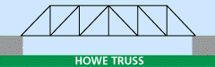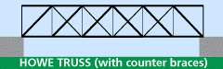
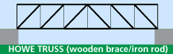
Friedrich August von Pauli (1802-1883) published details of his truss design in 1865. Probably the most famous Pauli truss, better known as the lenticular truss -- named because of the lens shape, is Pittsburgh's Smithfield Street Bridge. Its opposing arches combine the benefits of a suspension bridge with those of an arch bridge. But like the willow tree, some of its strength is expressed in its flexibility which is often noticeable to bridge traffic.
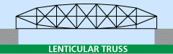
Before the use of computers, the interaction of forces on spans which crossed multiple supports was difficult to calculate. One solution to the problem was developed by E. M. Wichert of Pittsburgh, PA, in 1930. By introducing a open, hinged quadrilateral over the intermediate piers, each span could be calculated independently. The first Wichert truss was the Homestead High Level Bridge over the Monongahela River in 1937.
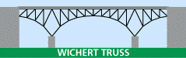
The composite cast and wrought iron Bollman truss was common on the Baltimore and Ohio Railroad. Of the hundred or so following Wendell Bollman's design, the 1869 bridge at Savage, MD, is perhaps the only intact survivor. Some of the counter bracing inside the panels has been omitted from the drawing for clarity.
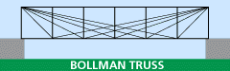
Also somewhat common on early railroads, particularly the B&O, was the Fink truss - - designed by Albert Fink of Germany in the 1860s.
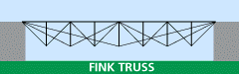

Cantilever types - truss
A cantilever is a structural member which projects beyond its support and is supported at only one end. Cantilever bridges are constructed using trusses, beams, or girders. Employing the cantilever principles allows structures to achieve spans longer than simple spans of the same superstructure type. They may also include a suspended span which hangs between the ends of opposing cantilever arms.
Some bridges which appear to be arch type are, in fact, cantilever truss. These may be identified by the diagonal braces which are used in the open spandrel. A true arch bridge relies on vertical members to transfer the load to the arch. Pratt and Warren bracing are among the most commonly used truss types.
The classic cantilever design is the through truss which extends above the deck. Some have trusses which extend both above and below the deck. The truss configuration will vary.
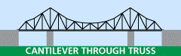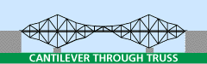

Suspension types
The longest bridges in the world are suspension bridges or their cousins, the cable-stayed bridge. The deck is hung from suspenders of wire rope, eyebars or other materials. Materials for the other parts also vary: piers may be steel or masonry; the deck may be made of girders or trussed. A tied arch resists spreading (drift) at its bearings by using the deck as a tie piece.
Pittsburgh was the site of the earliest wire rope suspension bridge, the Allegheny Aqueduct carrying the Pennsylvania Mainline Canal. A similar structure still stands at Minnisink Ford, NY, crossing the Delaware River. John Roebling and his son Washington Roebling, later famous in building the Brooklyn Bridge, began their work in Saxonburg, PA, north of Pittsburgh.
