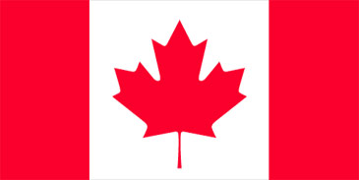
4 Years Ago
John Kerry
Vote!
This Oct. 21
For president
Drugs from Canada
Said he would work on it.

