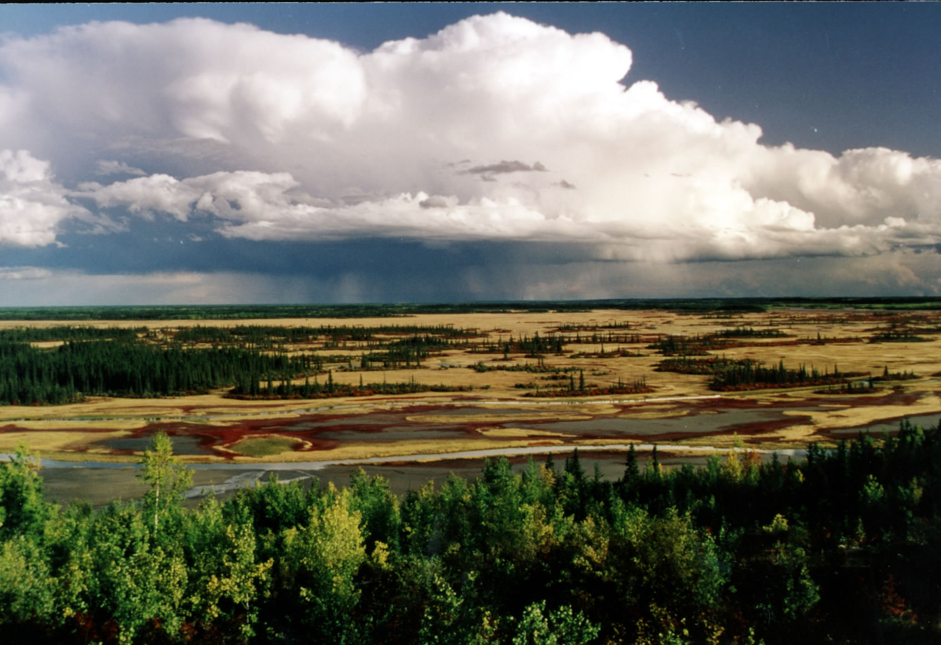
Moving West
By:
ichael Plasmeier
© 2005 M-Michael Publishing
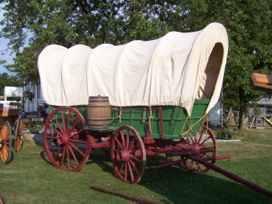

In 1840,¹ many settlers waved goodbye to their old homes forever, and set out to travel 2000² miles on the Oregon Trail.

They set off from jumping off towns where they loaded their provisions. They cold only take what was needed. The trail was rough and tough, so nothing extra could be brought. Still, they had to set out with lots of food for the trip. They took 200 pounds of flour for every adult³. They traveled in wagons called prairie schooners⁴. The trip was very expensive and very dangerous ^{E}. Cholera was a disease that killed on the trail⁵. Crossing fast moving rivers also proved to be very dangerous. Animals and Native Americans attacked settlers. Some say there was almost a million ways to die on the trail. In fact, there is almost 1 grave for every 80 yards on the trail⁶.
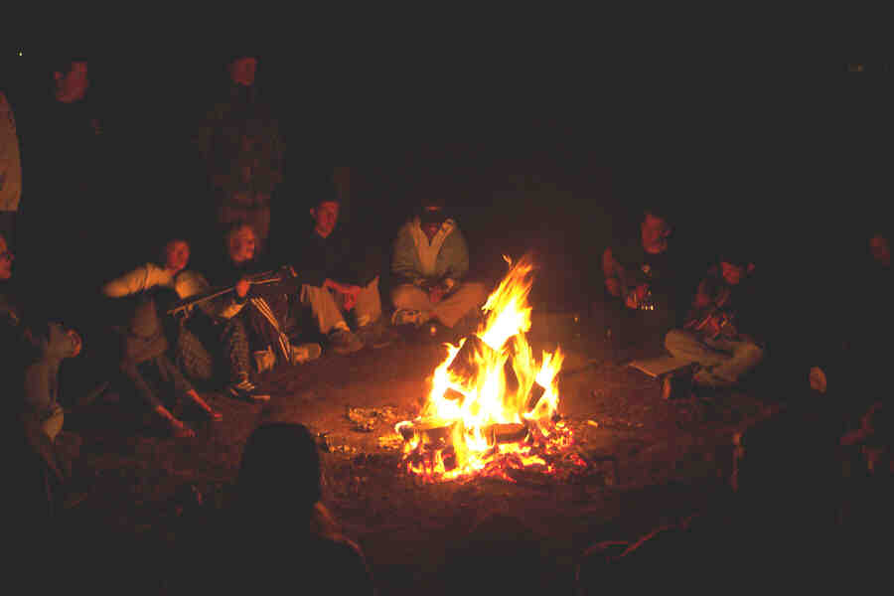

The settlers left town feeling like they were on vacation. They didn’t know of the dangers ahead, and felt like they could make it to their new life in California. The settlers hoped to make 20 miles a day⁷. They often didn’t reach their goal. They set out each morning bright and early by cooking breakfast. They started moving at 7AM, and kept walking till noon⁸. Then they stopped to have lunch. They started walking and walking again till dinner. Most of the settlers walked almost the entire way⁸. Can you walk 2,000 miles across the continent? When they stopped at 6PM for dinner, they circled up their wagon trains. They did this to keep the animals in, not to keep the Native Americans out⁹. They ate what food they had for dinner. Usually it was the same meal everyday like flapjacks and pancakes. Sometimes, the men killed an animal to eat for food. After dinner, everyone gather around the fire to tell songs and stories¹⁰. This was their only fun on the trail. Afterwards, the women and children slept, while the men took watch. They next day, the endless cycle of days started again.
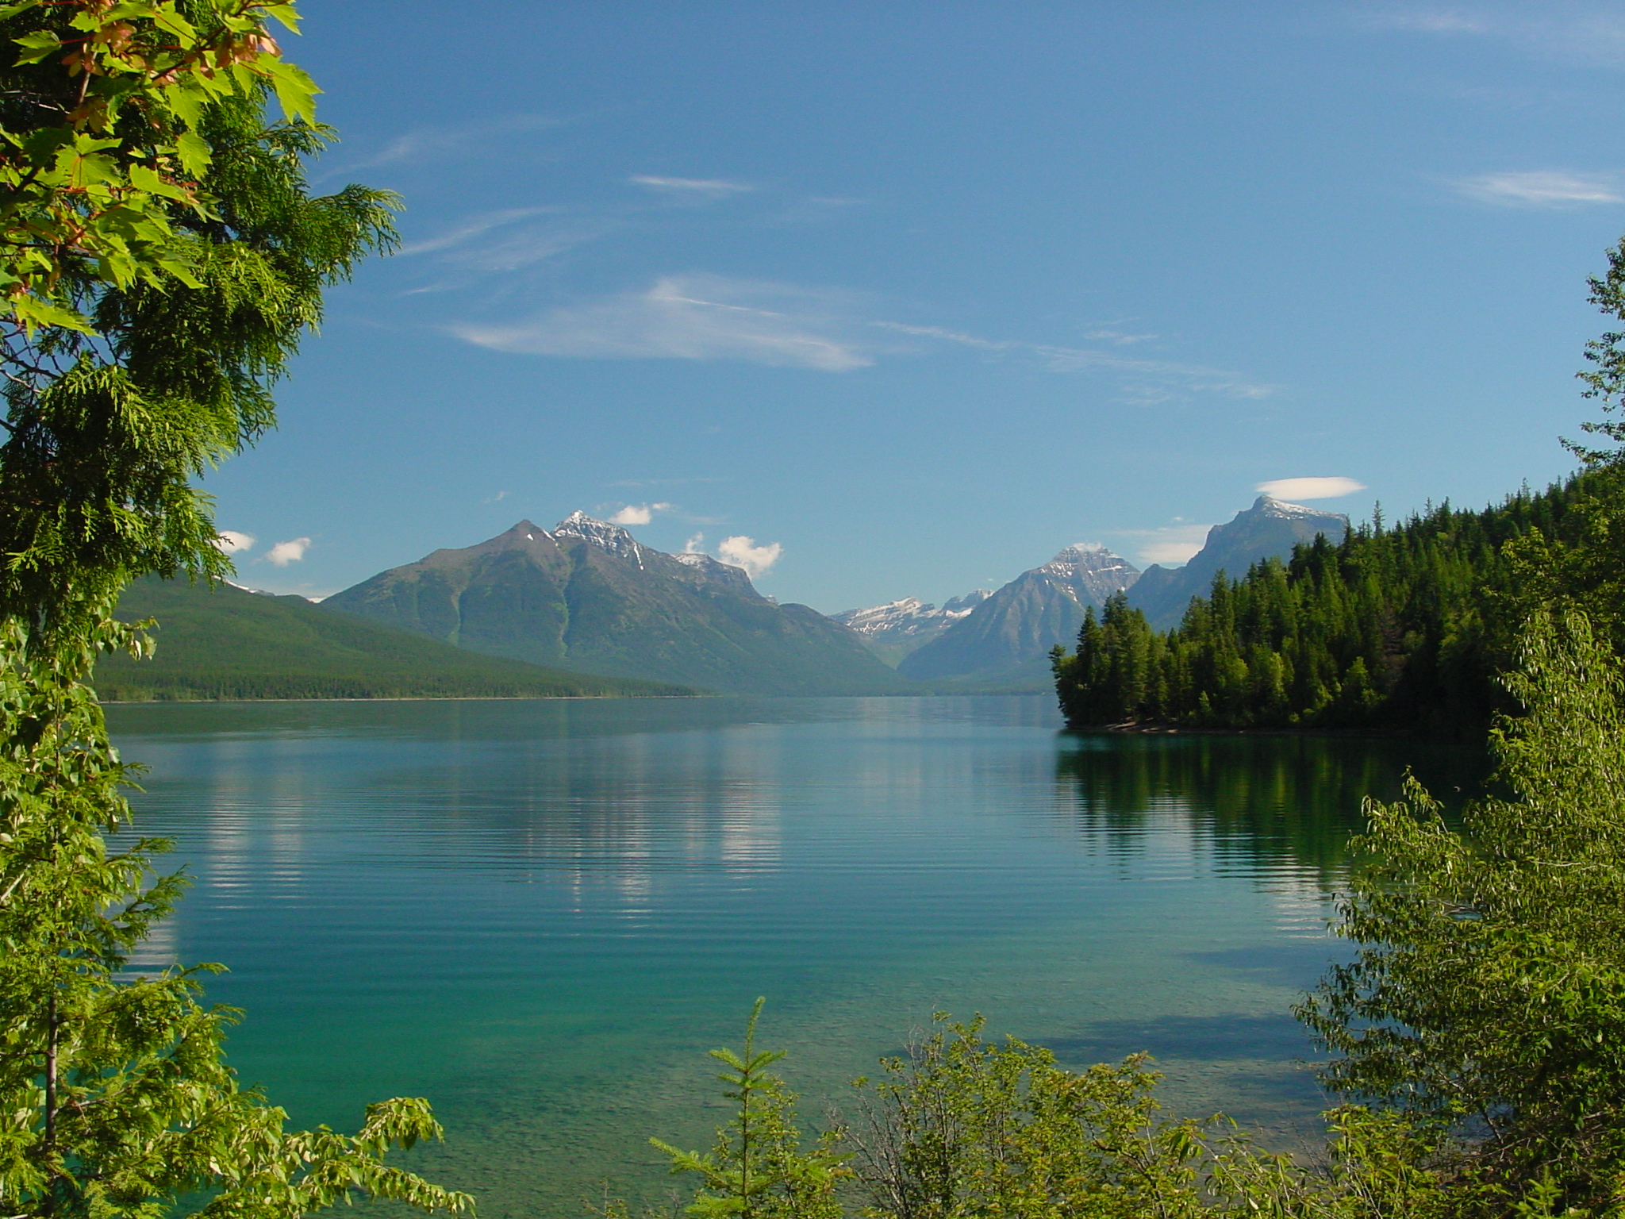
Why would any one want to travel on the Oregon Trail? There were 2 main reasons ^{D}. One is that people were “pushed” out of their old homes in the north and south. Crowded tenements and bad jobs at factories pushed people out. Also, some didn’t have any land or just arrived in the new world. Some were also “pulled” into the west by free and plentiful land¹¹. The wide open spaces, lots of fish, and fertile soil all attracted people to the west¹². Still, getting to the west was very dangerous. The journey was long and dangerous. Still, some believed that it was their destiny and America’s destiny to expand out west. They believed that it was their god-given right for American to stretch between the 2 oceans. This belief is called manifest destiny ^{A}.
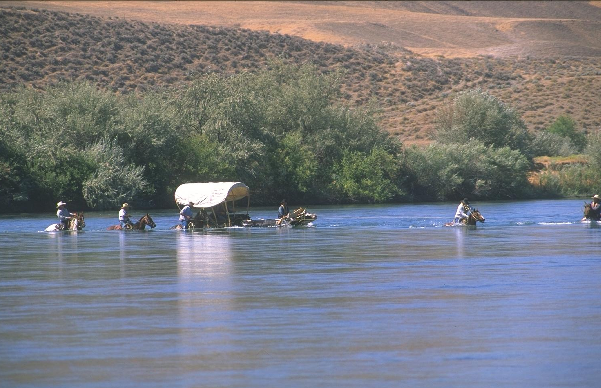
Most people were considered equal on the trail and in the west ^{B}. All of the settlers suffered from the same harsh conditions and wilderness. Being rich or poor did not matter as much as surviving. All wagons still had to go over the same mountains and cross the same rivers.

The west was impacted by other regions before developing into it’s own place ^{C}. Cities from both regions expanded outward, and settlers brought their customs along on the trail¹³. The settlers from the south brought along their slaves and knowledge of farming. Northerners did not like slavery in the south and also did not like it in the west¹⁴. The people from the south said that they needed their slaves to do the work. This led to a big controversy in the west.
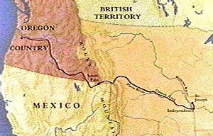
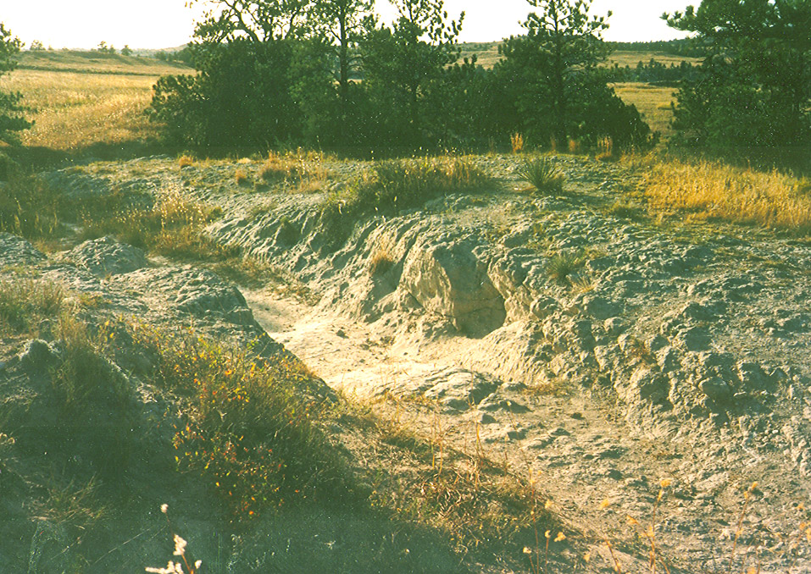
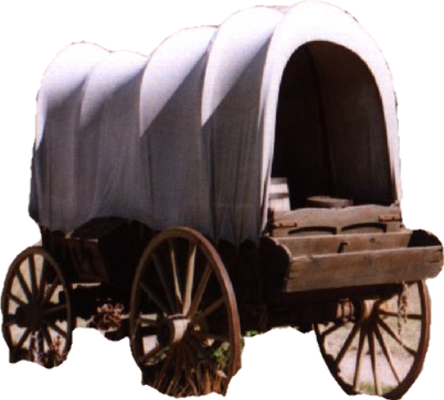
When the settlers left the jumping off town of Independence, MS, they followed the Santa Fe trail for 40 miles¹⁵. They then followed the Platte River to Fort Laramie¹⁶. The main trail then went through the mountains by the South Pass to the basin of the Colorado River and then to Fort Bridger¹⁷. The trail then went northwest across a divide to Fort Hall, on the Snake River and then to Fort Bosie¹⁸. From that point the travelers had to make the hard climb over the Blue Mts¹⁹. Once those were crossed, paths diverged somewhat; many went to Fort Walla Walla before proceeding down the south bank of the Columbia River, through the Cascade Mts. to the Willamette Valley²⁰.

(info from http://www.factmonster.com/ce6/history/A0860160.html)
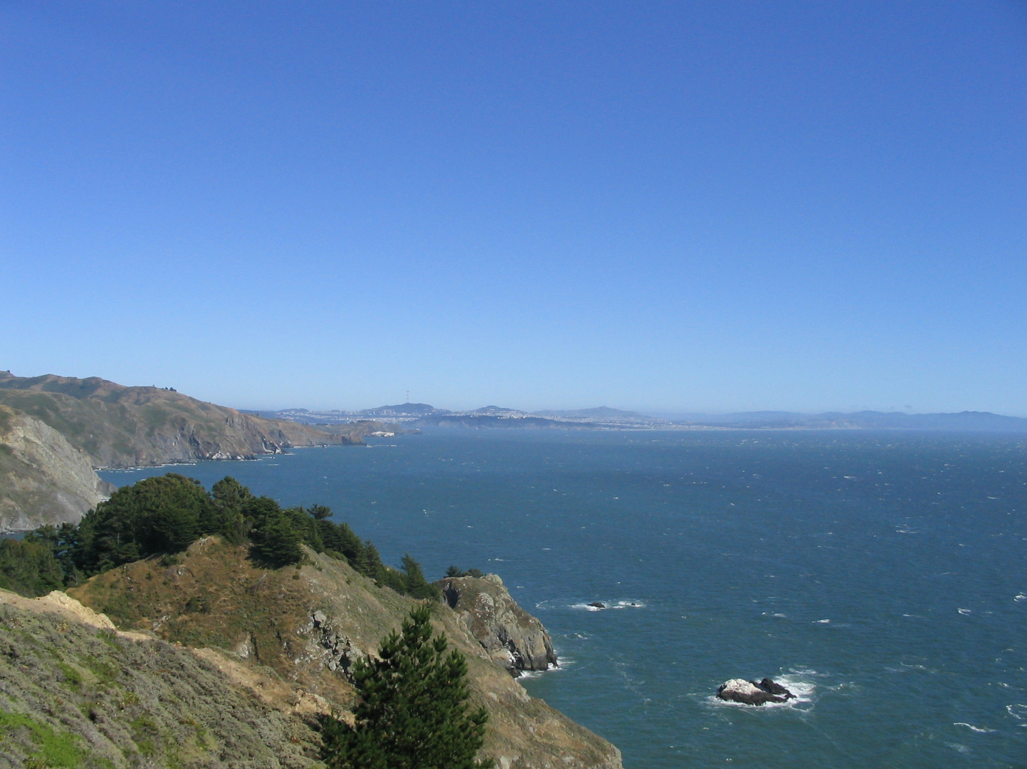
When the families finally made it to Oregon City before the snows closed the mountain passes, they celebrated. But after the celebration, the hard work returned. The settlers had to build their houses before the winter came. In the spring, it was back to planting crops and the hard work of farming. Life returned to normal, though hopefully, better then before.
sailboat

The Oregon Trail, and its travelers will be remembered forever. Wagon ruts still remain where the trail passed, and settlers’ names are still engraved in the rock near the trail²¹. The trail brought thousands of immigrants till railroads took over. The trail is still followed by US Highway 61²². But the settlers will be remembered with its spirit of adventure and thoughts of a better life. It was the largest voluntary migration in human history²³.

