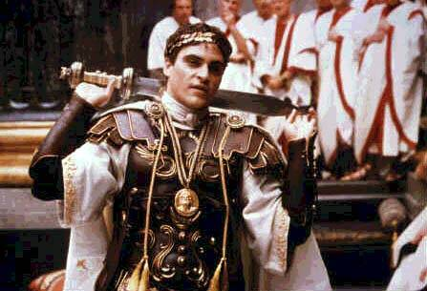
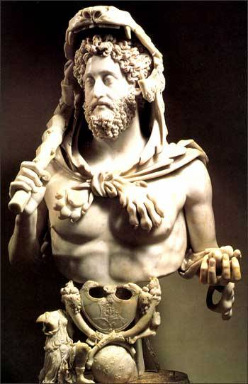

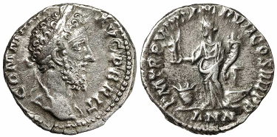

- Son Marcus Aurelis and Faustina
- Born in Lanuvium 161 CE
- Spent teen years on the frontlines with his father
- Educated intellectually, not militarily

Caesar age 5
Germanicus age 11
Imperator age 16
Co-Augusts age 17
Emperor age 19
God age 29
Dead age 31
Megalomania
- Obsessed with Hercules
  - Carried lion skin and a club
- Fought in the Coliseum (always won)
  - Considered scandalous
  - Charged 1 million sesterces/fight (lots of $$)
- Great archer
- Refounded Rome (so he could claim himself as the founder)
- Renamed the months to correspond with his titles
- Renamed the population Commodianus
- Made the years correspond to his age

- Several attempts made on his life
- On 31 December 192, an athlete Narcissus strangled him in the baths
- Senate rolled back most of his changes
- After him the year of the five emperors
- After father’s death, surrendered to tribes, people had high hopes, thought he would rule like his father
- Coins showed him as warrior
- Popular for most of his rule
- Generous
- Taxed the Senatorial class
  - Made him popular with the people
  - But disliked in the Senate

- Why was Commodus murdered?
- Why do you think he was crazy?
- Did his intellectual education cause him to rebel?

- “Commodus” Wikipedia
- “Commodus” Encarta (pay edition)
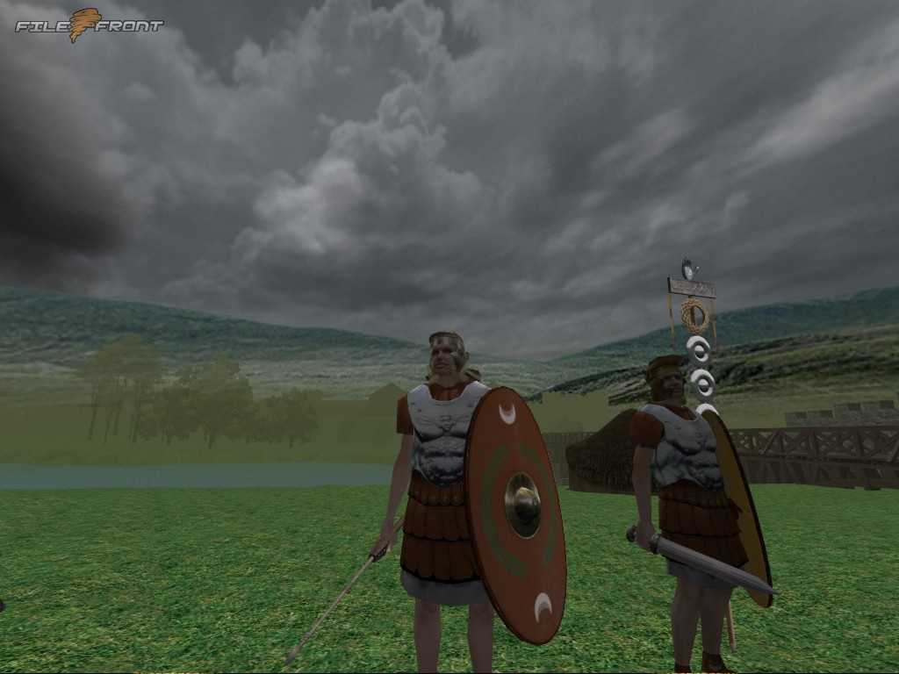

- http://www.roman-emperors.org/commod.htm

