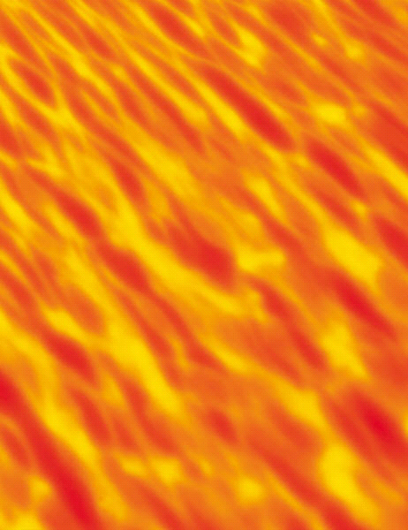
I am in a dark and confusing maze. I’m here. Somehow I’ve been left behind. I don’t know how I got here. Why am I here? I look around; my worst fears are coming true. I am beginning to hate being here. The ceiling is low, and the hair on my back is starting to stand up. I am scared. What’s going on? Bang! A shot pierces through the air. I duck and it passes were I just was a second ago. Swoosh! Another one passes by. What can I do? How can I escape? Where can I go? The ceiling is starting to drop down. Whoosh, I hear it descend a notch. It’s close now. It is almost hugging me. Creek, it moves ever closer to me. I look around. It is dark, but I can see the outline of a maze. What can I do? Why am I here? This is my hell. I can feel it all the way to the bottom of my bones.
I look around, my eyes open. Where am I now? Where was I? Was it a dream? What’s this? I see that I am in my bed now. It’s just my room and it seems like nothing happened. But something did happen. I saw it. I just can’t figure it out. I lay back down on my bed. I start to drift back to sleep. The dark envelops me. Once again, I am in a dark and confusing maze.
5th Draft
Key:
- Onomatopoeia
- Sensory Images
Grrr, the ceiling is still lowering. Time is running out. I can’t see. What can I do? I have a feeling to go through the maze. NO! Then I will get more lost. What can I do? It smells of bleach, like the hospital, the dentist office. I want to move but I can’t. Something’s stopping me. The ceiling is almost at me now. It will crush me. I can taste the salty air, and it’s choking me. WHAT CAN I DO?? WHERE CAN I GO???
Michael Plasmeier
7/31/2026
P.D.:4

