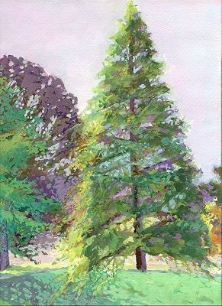
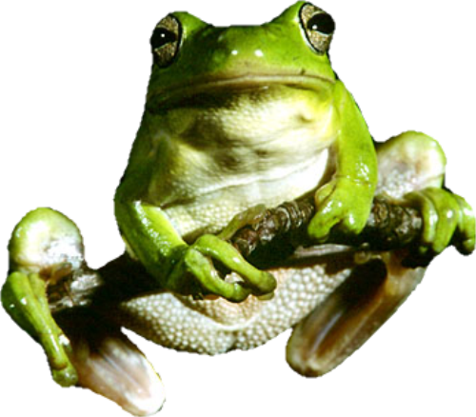
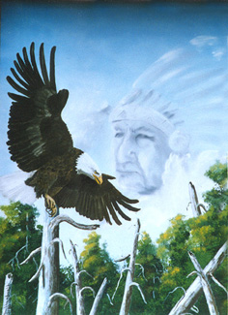

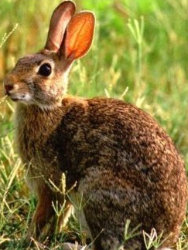
Michael Plasmeier
7/29/2026
P.D.: 4
Narrative Legend

FCA’s:
1. Similes/ Metaphors
2. Intro/Body/Conclusion
3. Cover/title/heading
Michael Plasmeier
7/29/2026
P.D.: 4
Narrative Legend

FCA’s:
1. Similes/ Metaphors
2. Intro/Body/Conclusion
3. Cover/title/heading

Do you ever wonder why evergreen trees stay green all year? It all happened because a certain evergreen tree, named Big Tree, was greedy. Because of this, evergreen trees around the world are cut down by white settlers every winter, and put up as Christmas Trees.

One day a long time ago, Big Tree stood tall in the forest. He was the king, towering above all of the other trees. He stood straight and tall like an arrow sticking out of the ground.^{s}

One morning a long time ago, Big Tree was just waking up to a new day in the forest. Then his friendly neighbor, Rabbit, pendulumed back and forth collecting food^{m}. He stopped and said, “Good morning, Big Tree! You look as grand as ever today.”

“Thank you,” replied Big Tree with a smile.

Next along came Mr. Frog. “Top of the mornin’ to ya, Big Tree. How ya doin’ today?”

“Fine, fine. How are you doing?”

“Wonderful.” Mr. Frog then hopped through forest.

For the rest of the day, Now, Big Tree was all alone. Big Tree went to thinking. He was depressed. Then, he thought about how much fun it would be to be green all year round. He would be more then just the tallest in the forest. He would be noticed in the winter.

The next morning, Rabbit came hopping along again. “Good morning, Big Tree! You look as grand as ever today.”

Big Tree replied, “Oh, no, I don’t. I want to be green all year long. Then everyone will notice me!”

“But you are already the tallest tree in the forest. I like you just the way you are. Being green all year round is a very bad idea. Please don’t do that.”

Next, Mr. Frog came along. “Mornin’, Big Tree. How ya doin’?”

“I want to be green all year long, and be noticed by everyone.”

“Noo, Big Tree. I think that is a totally terrible idea. You are already the tallest tree in the forest. What more do ya want?”

“I want to be green all year long.” As Mr. Frog hopped away, Big Tree went to thinking. He didn’t care his fine friends said. Big Tree then summoned the Great Spirit anyway. The Great Spirit had the power to turn Big Tree green all year long.

“Whatta ya want with me? Can’t ya see I’m busy. No one can ever get any rest ‘round here ever since ya could talk.”

“I want to be as green as the grass^{s} all year long. Summer, fall, winter, spring, all green, all the time. I want to stand out and be noticed! I want to be different!”

“That is a terrible idea, Little Tree.”

“It’s Big Tree. Big Tree. Are you blind?”

“No! And thanks for askin’. Ya don’t want to be green all year long. You will see what I mean. White men will come and cut ya little self down to a stump!”

“I don’t care. I want to be different. I want to be set apart like black from white^{s}.”

“Oh all right already. Just don’t be commin’ back to me and be askin’ me to change ya right back. Ok, POOF!” From this point forward, Big Tree was green all the time. The Great Spirit disappeared and Big Tree eagerly awaited Fall to show himself off, while the others were bare.

When Rabbit and Mr. Frog saw Big Tree that fall, they laughed and told him that he looked ridiculous. Still, they were very mad that Big Tree wet against their wisdom. They thought that Big Tree no longer interested in being their friends and that he rather attract other’s attentions. Rabbit and Mr. Frog decided that they would never talk to Big Tree ever again. Big Tree, however, wasn’t mad that he had lost his friends for the first winter. However, the seasons started dragging into years. No one else cared that Big Tree was green all year long, and soon neither did Big Tree. Then in a few years, Big Tree started having Little Trees that stood around him. These were his pride and joy.

Big Tree’s children lived in the forest, day in, and day out. Till, a few years later, two white settlers came trudging through the peaceful forest, making heavy tracks in the snow. The settlers stopped at Big Tree and his children. They started to chop down the little trees. When the men had left with Big Tree’s kin, Big Tree was very sad. He had no one now. He couldn’t talk, he had no friends, and being green wasn’t very fun.

So, Big Tree lived on year after year very lonely. If only he hadn’t been so greedy to be green all year round. He already had lots of friends and was the tallest tree in the forest. So his greed had removed all of these things from him, his children, and his friends. So, the moral of the story is, don’t be greedy, take what you already have, and don’t always want more.

P.S. If you wondering what happened to Big Tree’s children, they were sold off and turned into Christmas Trees!

