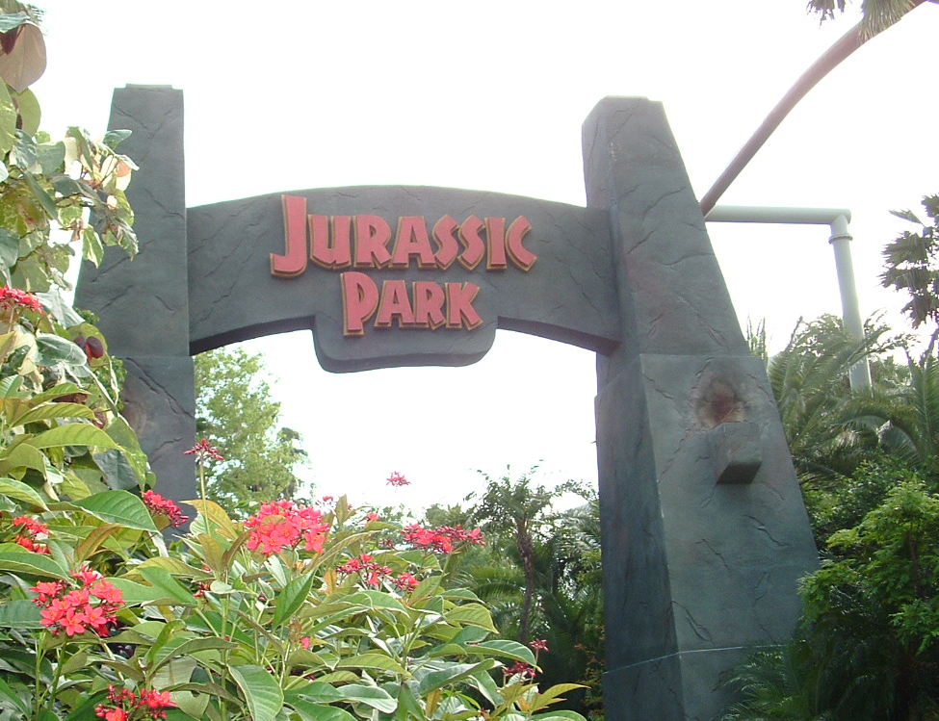
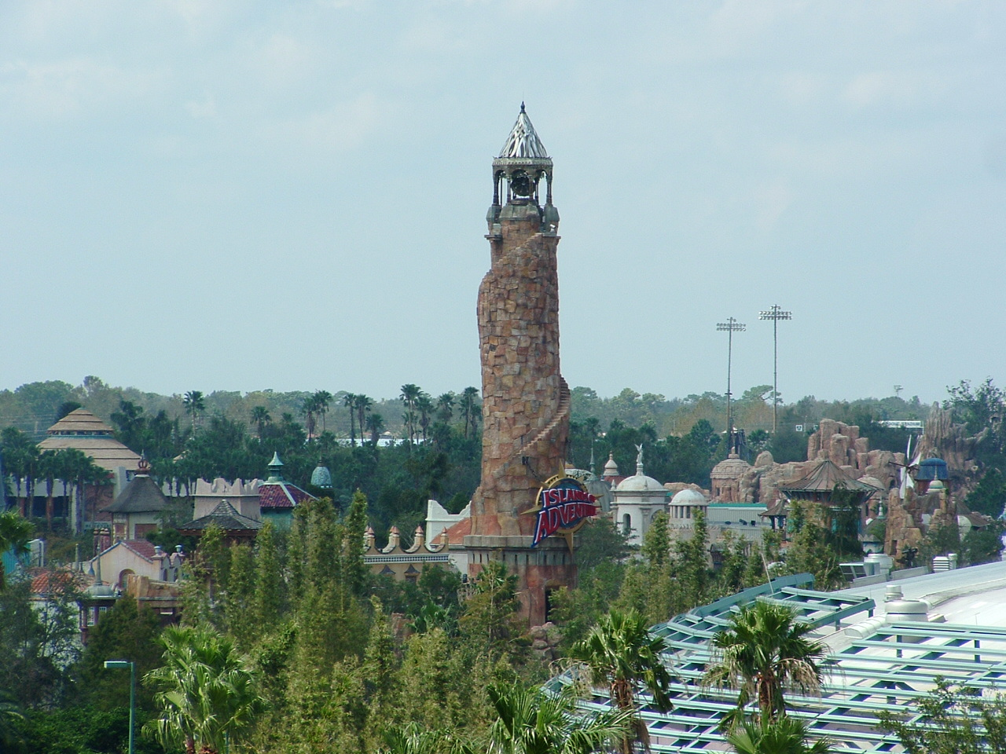

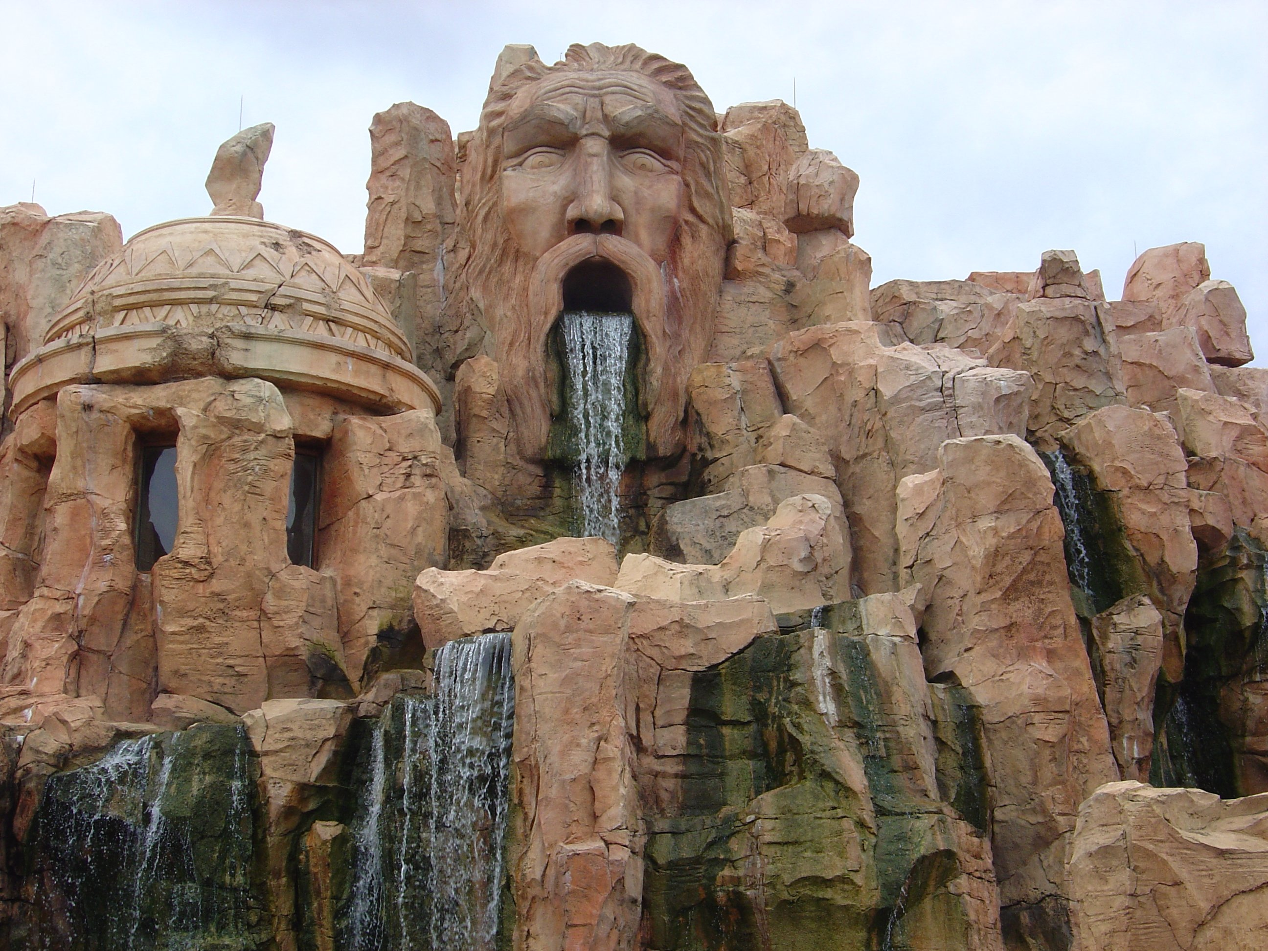


Happy Days
The wind whispers over the bridge.
The belt groans over my weight,
Traveling back and forth over the ridge.
Time to get off, adventures await.

The sky loves me,
It smiles down at me.
The rain is afraid,
Of this beautiful day.

I walk down the street.
Soon my feet will groan.
My eyes are astounded at the wonder.
All around me, that I see.

The gate squeaks,
Eats my ticket,
Then spits it out.
I’m in!

“The Adventure Begins,” reads the sign,
Shouting loud for all to see.
That’s it.
I’m in my happy place!
It’s going to be a happy day for me.
4th Draft
Michael Plasmeier
7/31/2026
P.D.:4

Pictures from universal-excitement.com

