Hatred
A few years ago hatred ruled,
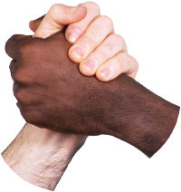
People burned, and trashed, and destroyed.
They ruined houses and lives,
And stuff in between.
Big and small things,
TV’s, cars, and dishes.
Why did they do this?
Why did they destroy?
Hatred

They hated differences.
They hated other races.
They were jealous.
Jealous at other people.
And that is why they destroyed.
That is why they trashed.
That is why they hated.
Hatred

People shouldn’t judge races.
They should judge people by what’s on the inside,
Not what’s on the outside.
They should judge by your feelings,
By their hope.
They should judge people by their strength to stand,
By their love for other people.
They shouldn’t judge by their skin color.
That brings hate.
Hatred

People should live together.
And they should not fight.
Like what happened after Martin Luther King’s dream came true.
They should all agree and unite.
They should not judge others and call them names.
For when we do that,
We form hatred.
Hatred.

Michael Plasmeier
7/30/2026
P.D.:1-2

