Michael Plasmeier
3rd Draft
7/29/2026
P.D.:4

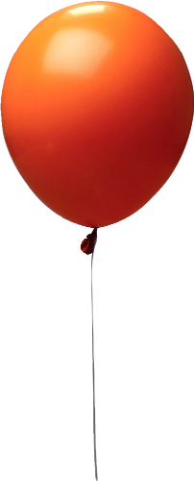
I am…


I celebrate me…
As I am different.
Different tastes,
Different music,
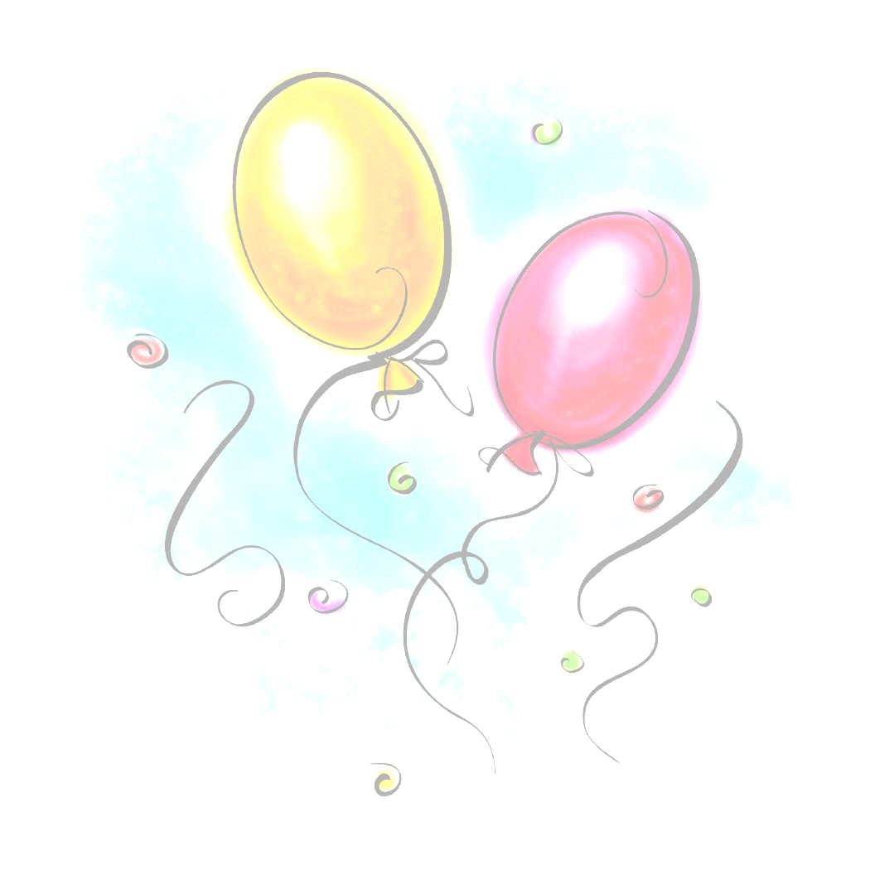
Different food.

Alone,
Together.

Things I love about myself:
Salesman,
Showman.

Computers,
Technical,
Classical,
Different.

Don’t like accomplishments,
Awards assemblies.
FAKE!

Different,


Over-achiever.
I Celebrate
Loony,
Conservative.


