
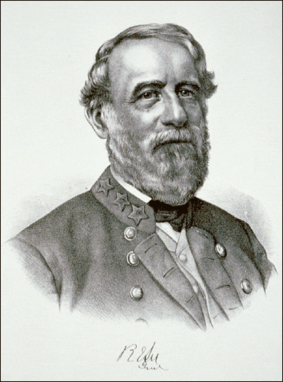
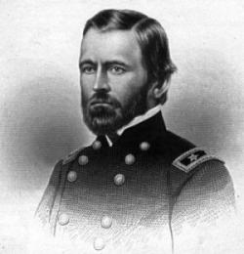

Robert E. Lee
Loyal, Psychic
Marching, Fighting, Wanted
Genus, Hero, Hero, Unknown
Rising, Attacking, Answered
Butcher, Winner
Ulysses S. Grant

