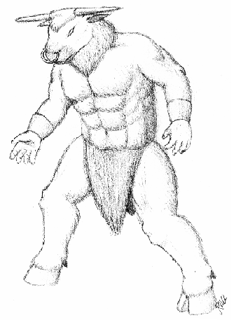
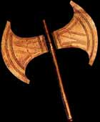
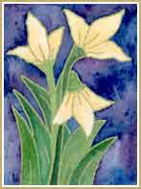
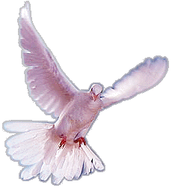
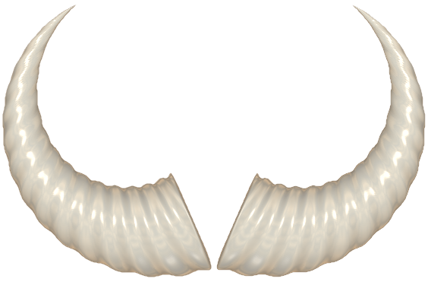
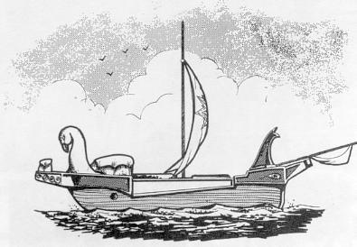
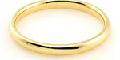
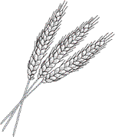
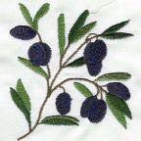
Minoans
Michael Plasmeier
7/30/2026
PD3
Minotaur running around the labyrinth in Knossos, on the island of Crete.
In 2800-1400 B.C. the Minoans lived.
No return for the teenagers from Athens, once they were placed in the maze, to be sacrificed to the Minotaur.
Olives, barley, wheat, and grapes, they grew and traded with their neighbors.
Aegean Sea and others they sailed in their wooden ships.
No walls surrounding cities, water did the job instead.
Shelter made out of sun-dried bricks and stones.

