## Scope

This team project started off poorly. We spent all of the in-class time arguing about scope. I think that one other team member had strong personal feelings about the project we were doing. I believe that this person was not willing to write stuff in the report that they were not comfortable with personally. I tried to remind this person that we were just writing a report for the purposes to write a report, and that the recommendations did not need to reflect his or her actual beliefs. In addition, I had to remind that person that we could cover something in the report and say that it was not recommended. The other 3 group members were largely apathetic through all this.

I think I may have slipped up and brought my personal feelings into the report. As a result, throughout the rest of the process I aggressively tried to separate the project from real life. I think this confused some of the administrators I talked to. I had previously been working with another girl from the Undergrad Association Committee on Student Life. Because this was a class report, I sought to meet the requirements of the project (having a letter of transmittal, etc) as opposed to trying to target the report to real life. I think that these dual goals messed me up. The rest of the team was not affected as much I feel.

## Organization

Our first organizational plan was centered on next steps: I was assigned to talking with administrators; someone else was in charge of a survey, etc. However, at some point as we started to put the paper together, I realized that it would be better to organize around sub-topics: location, time, curriculum, PE credit. I emailed out but some of my group members did not snap up on a section. In addition, old vestiges of the old organization scheme were visible in the draft paper. For example, all of the survey data was analyzed in one section, rather than in a central section.

This only got fixed as I pushed people to snap up sections. I realize now that sections were very uneven – largely proportional to how willing people were to take on additional work. One group member slunk out of doing anything more than a very small section.

## Draft

We, myself included, did very little in the first few weeks of the project. I personally treated the project as low priority. We did not meet at all or talk over those weeks. I did schedule meetings with administrators, but I missed one from Carrie Moore about PE credit. This caused me to not be able to complete the section in time for the draft.

On 4/8, I realized that we needed to get the draft done – and we had barley started! I took charge by sending to flowing email to the team

I just realized this is due next week.  We need to bang this out sometime.  This weekend is bad (CPW), but we need to set aside several hrs this week to put this together!!!  Is everyone clear what section you are working on????  Do you know what needs to be done to complete this?

Because it was CPW weekend, I had very little time to work on the paper. I ended up getting into the role of being the organizer for the paper. I emailed each person for their sections. I asked for them 10PM the day before it was due, but because of other homework, I started working at around 12AM. I got the whole team to get on Google Chat while I copy and pasted, without reading, the sections together. I then put in an intro and a conclusion in. One group member still did not have their section in by 2AM, so I sent them the report and told them to put their section in and print and bring the paper to class.

I was very surprised by the grade we got on the draft for having put the thing together on the last day.

## Revising and Meeting

After getting the draft back, I continued my self-appointed role as project leader. I took the graded draft home to scan. I also pushed for a group meeting. When no one wrote back confirming a meeting, I just scheduled one. I also went through the draft with a red pen and made comments on everyone’s sections, and scanned and sent this out as well. I made it clear that I thought we could improve the report and I mentioned the meeting several times.

I am really proud of how I led the team meeting. I continued my role as project manager when I subconsciously took a seat at the head of the table. I started by going over your and my edits to each person’s section. I made it clear how I thought each section could be improved. I then focused on the major recommendation that was provided on the draft: have a recommendation. I then guided the group’s discussion of a recommendation for each section. I tried and succeeded to build consensus by having the group member responsible for each section come up with a recommendation. I then asked everyone if they agreed. The group members also asked me for clarification on my handwriting.

A dining event was going on at the same time. As Richard Berlin, director of campus dining, was leaving, I grabbed him and asked him to talk to our group for a few minutes. One of our group members got his/her question answered and another heard useful information to add. The meeting ended when Tom Gearty, Special Assistant to the Dean of Student Life walked in the room and announced that left over snacks were available. This caused our group to disperse, ending the meeting with Richard. I sent Tom a nice email that I did not appreciate this – I am sure he did not realize, but I wanted to let him know. I also did it to “rebalance” our relationship (Tom and I have spoken many times in the past few months and I think we generally have a good professional relationship)

## Final Project 4/28/2011

So it is 1am the day before this project is due and I am waiting for 2 of my group members to write in. I have not heard from then since our meeting ended at 7pm. One group member said he was going to stay in the conference room till he or she finished his/her section. I doubt that now, since I don’t see work from him.

I’ve spent the last few hours integrating sections people have been sending me. I particular I had to re-write two sections almost from scratch. One of my team members is really hyper and upbeat when presenting information, but unfortunately does not share the same enthusiasm for presenting factual information. The information gets fairly nuanced, but you have to present it accurately. For example, one person we spoke wanted to offer cooking classes of their own. Although I told them about our program, they did not say that they were willing to staff our program. This distinction needs to be made clear. Often it is made clear subtly: “the company supports a cooking class”, and not “they will do our cooking class.”

In addition, I had to fix a far more serious problem: our stats were wrong. I had told the person who put the stats together this, but that person only made minor changes when he/she resubmitted his/her section to me. For example, this person wrote “77.1% females and 22.9% males would be interested in the cooking class.” Despite me pointing out to him/her that this was incorrect (see appendix A), the text was resubmitted as is. These numbers are actually saying that 77% of our respondents were female! Now one could argue that only people who support the program submit the survey, but this should be explained. In addition, one should actually look at the claim that the original group member was trying to make. I asked him/her for the survey website password and I did my own data diving. This is the chart:

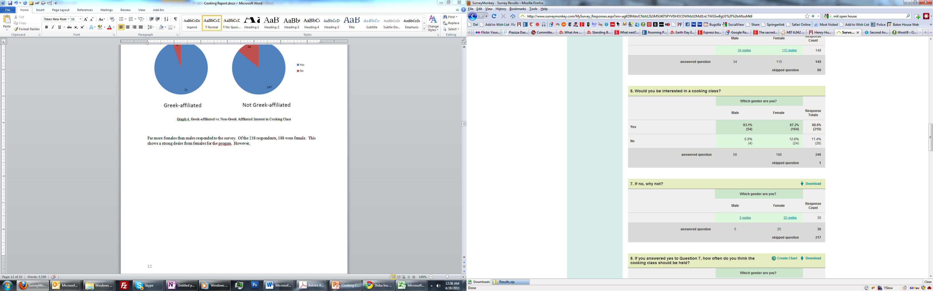

Of the men that responded, men are actually more favorable to the project percentage wise!

The problem also repeated itself in the Greek data. This is the original graph. One would have to look at the caption to see that this was only the people interested in cooking classes. The author concluded “69.8% of those who are interested are not Greek-affiliated, as seen in Graph 4. This could be because many Greek programs have a cooking rotation program which exposes students to those skills.” However there are more non-greek people at MIT, and we sent the survey to mostly non-greek people. So all this graph tells us is that most people at MIT are non-greek!

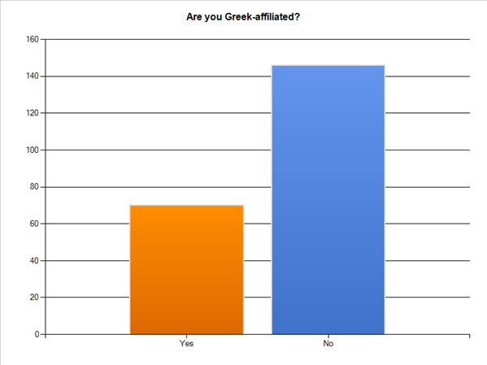

Graph 4. Greek-affiliated vs. Non-Greek Affiliated Interest in Cooking Class

I pointed this out as well. The person’s new graph at least tried to show how many people who responded were interested in a cooking class. However the author’s analysis was still wrong (but longer)

“69.8% of those who are interested are not Greek-affiliated, as seen in Graph 4. This is likely because the Greek houses have a chef who cooks dinner every night. These houses include 4/6 of the sororities, and probably includes about 22/25 fraternities. Almost every affiliated non-freshman male lives at his fraternity house and most freshmen boys spend every day there. For the sororities, not as many sisters live in the house, but they are allowed to go there for dinner whenever they want to. There is a high interest for non-Greeks because they have to fend for themselves in terms of food. Some of the fraternities even provide lunch every day, and all houses have staple breakfast and lunch foods like cereal, eggs, milk, yogurt, bread, cold cuts, etc. This is also probably why more females are interested in the program than males, as shown in Graph 3.”

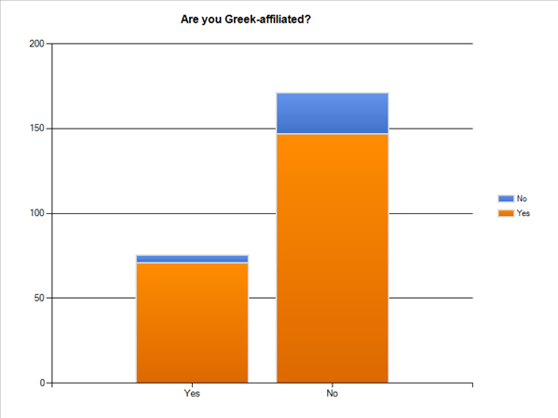

If you actually look at the data, the Greek people who responded are actually more interested percentage wise! He is the chart I made



If that person would be working for me, I would fire them on the spot for statistical stupidity!

Goodnight!

## Appendix A