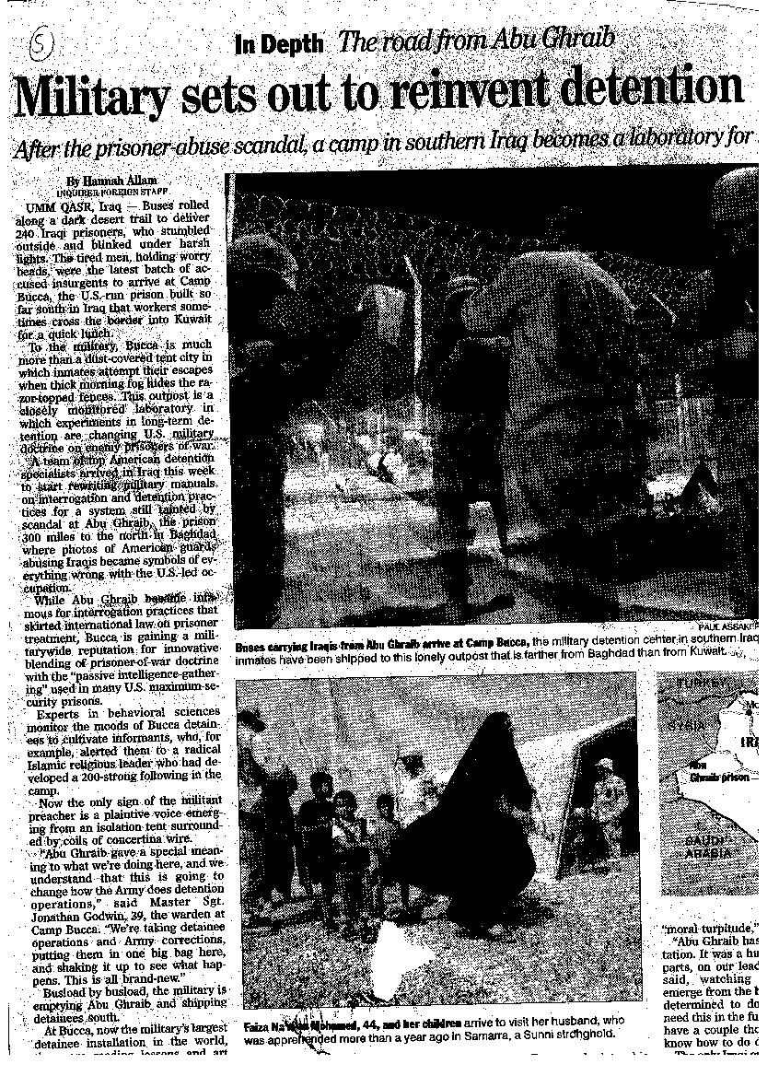
The founding fathers knew that they would need a militia to protect the country from outsiders. They wanted to have a stronger army then the Articles of Confederation provided, because under the Articles of Confederation, the states did not need to provide soldiers. The preamble of course, does not give the order to provide for the common defense, it just states the principal. (See Note)

This article is about our army oversees in Iraq. They are setting up a new prison, Camp Bucca. This new prison is very different from Abu Ghraib, the site of the prison abuse scandal. Our military is oversees trying to protect our country from terrorists and those who want to harm us.

