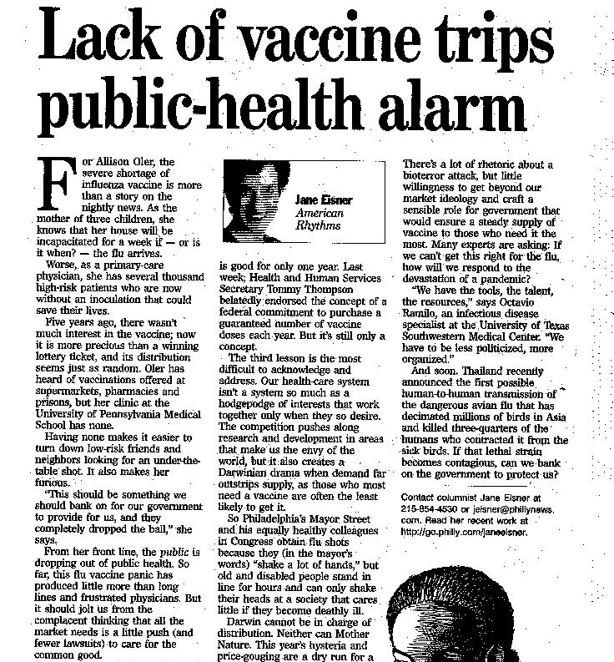
The government of countries are suppose to support the well-being of it’s citizens. The founding fathers knew this and included it on the Constitution. Of course, this is just a principal, it is not actually guaranteeing it. (See Note)

This article is about the lack of vaccines for the flu. Earlier in the year our supply was cut short when one company’s vaccines were pulled from the shelves. The lack of vaccines has forced long lines into hospitals just to find out that there are no vaccines left. The article goes on into an opinion that our government did not do enough to stop this problem and to protect our welfare. They also think that our government should protect us from this problem in the future.

