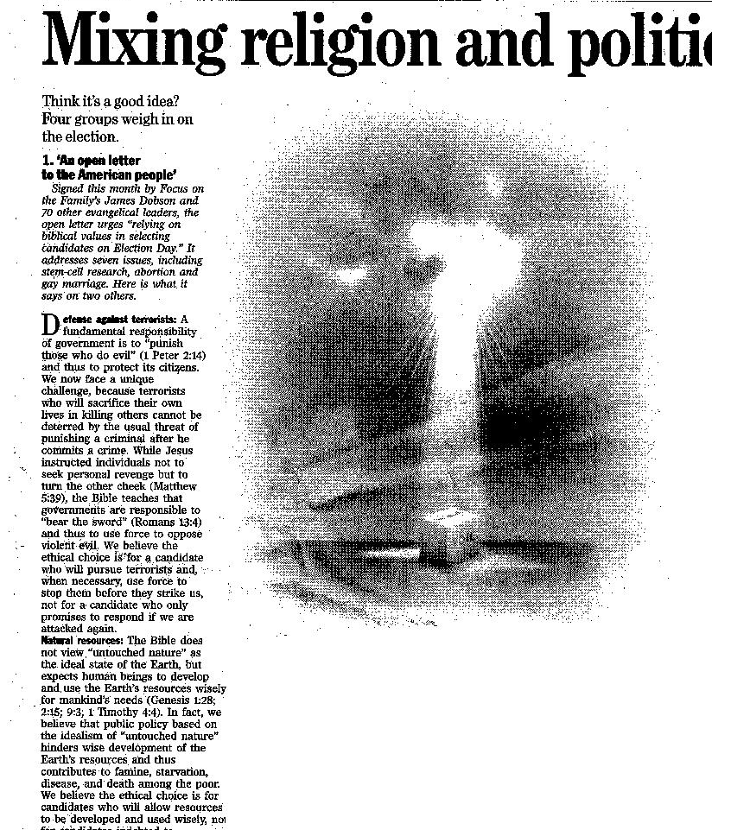
The Declaration of Independence gave our citizens freedom and liberty. The Constitution wants to continue that notion, one on which America was born on. They want the country to grow and continue on for our posterity. Again, this is just a principal. (See Note)

The constitution states that we should be free and in the Bill of Rights, it grants us that freedom of speech. This article gives the opinion on why someone should vote for President Bush because of “fath-baised values.” I happened to disagree with the article, but freedom of speech lets everyone have a voice. Liberty is a freedom that we are insuring for our posterity (our descendents in the future.)

