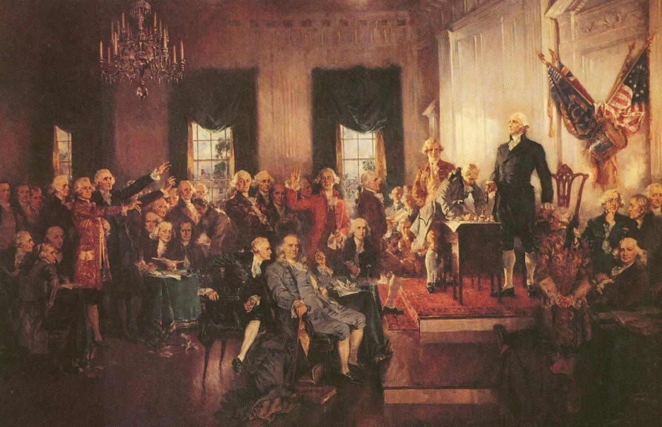
This is the closing of the Preamble. It merely states that the founding fathers support and send off the Constitution. It also says who we are, the United States of America.

This is a picture of the representatives of the Constitutional Convention. They are establishing the Constitution by signing it and sending it away for the states to ratify.

Note: In 1905 the supreme court decided in Jacobson vs. Massachusetts, that the Preamble does not guarantee citizens anything.

