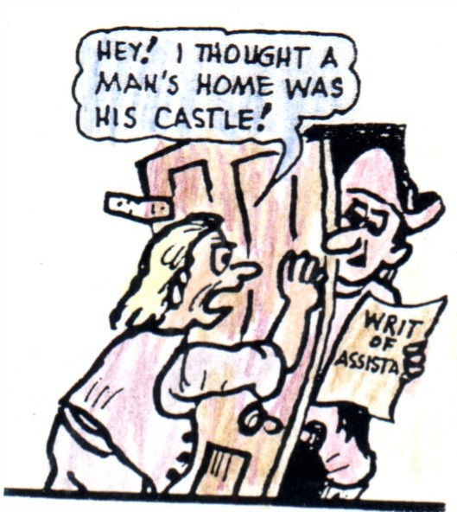
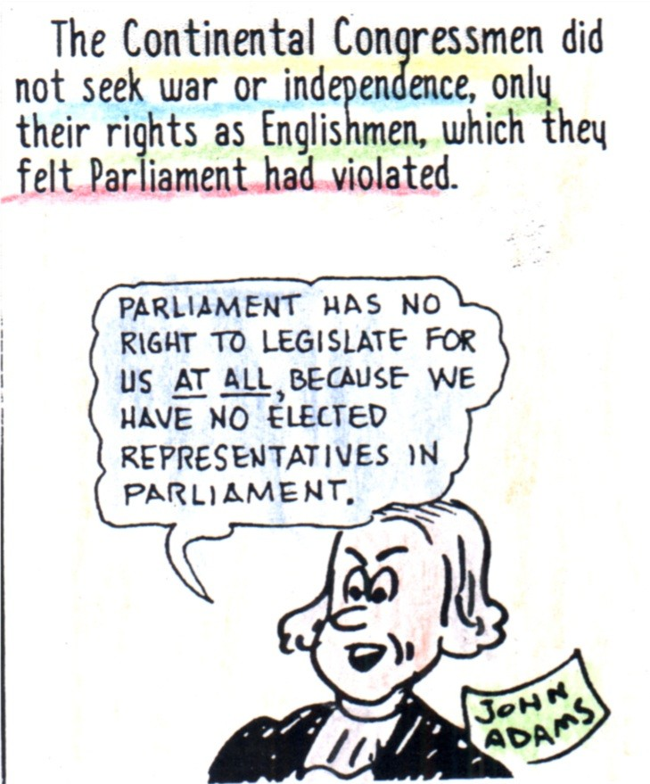
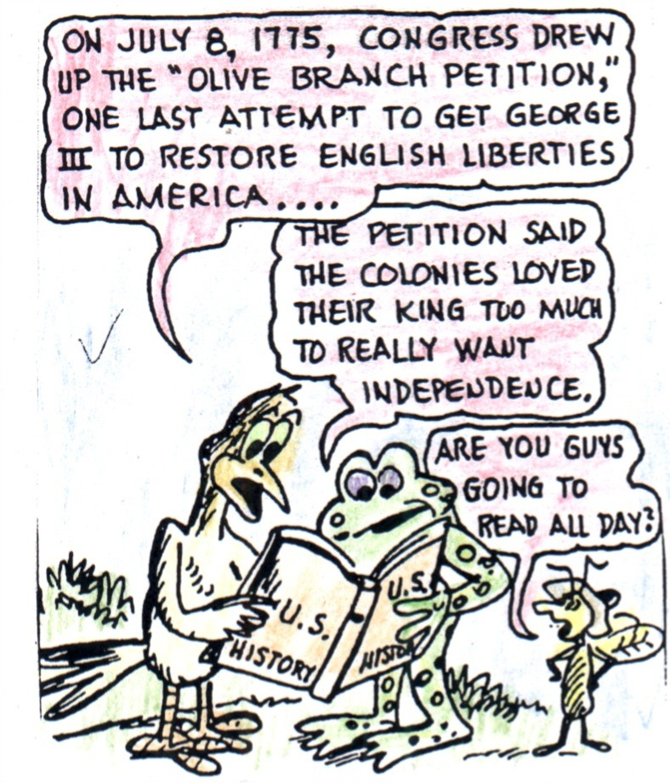
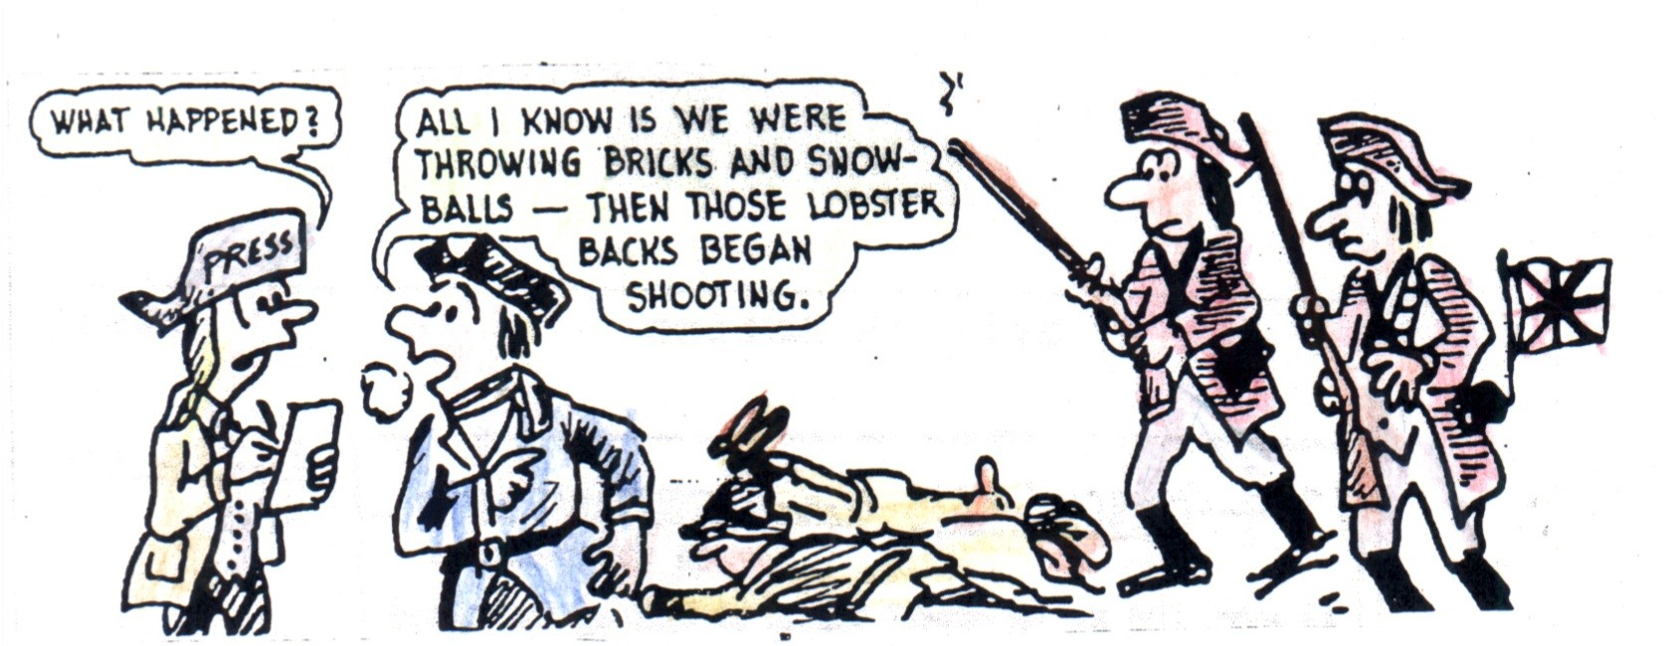
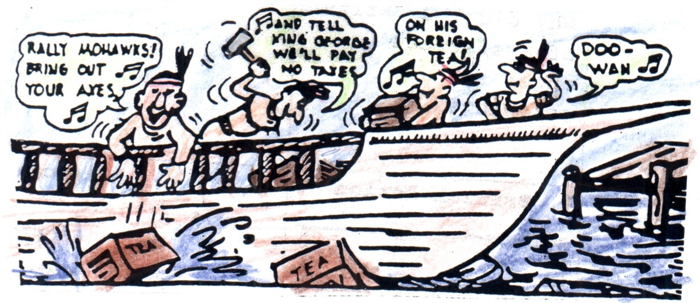
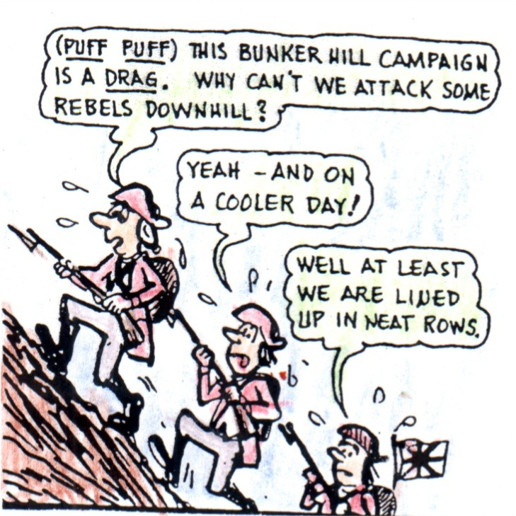
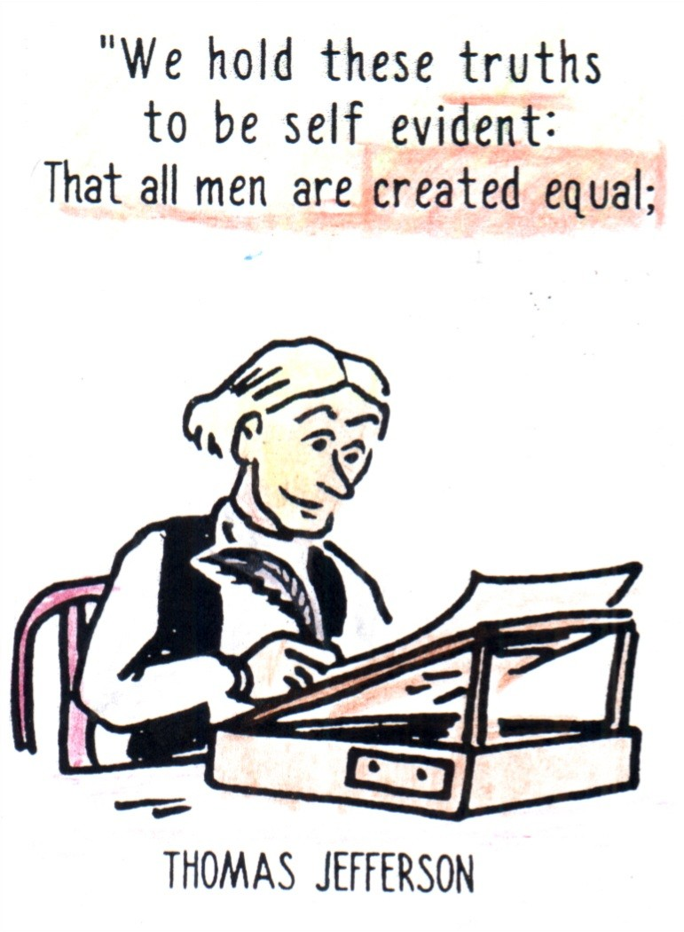
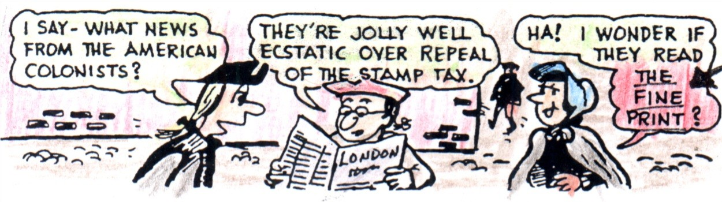
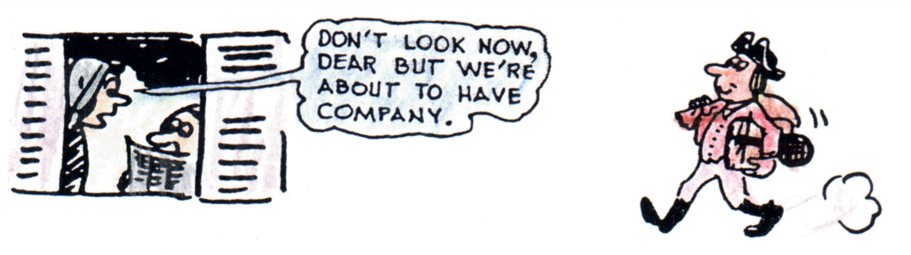
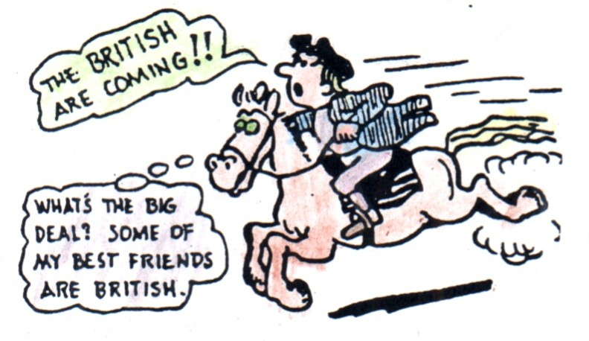
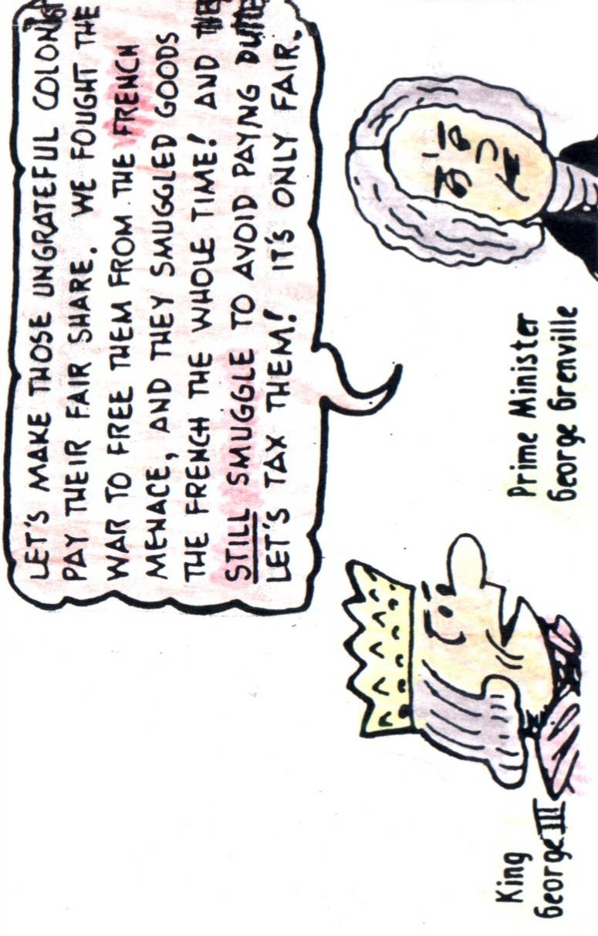
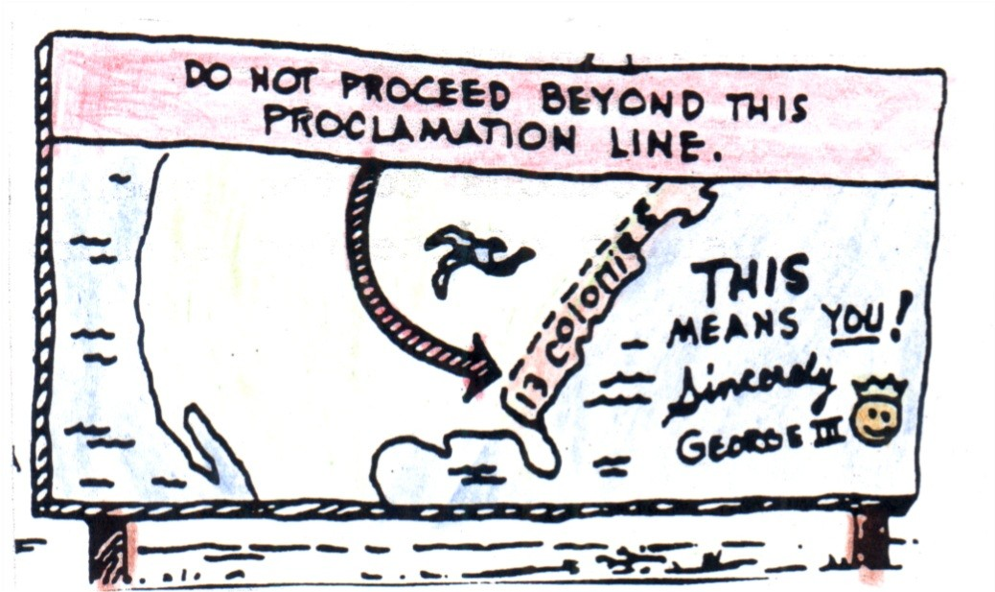
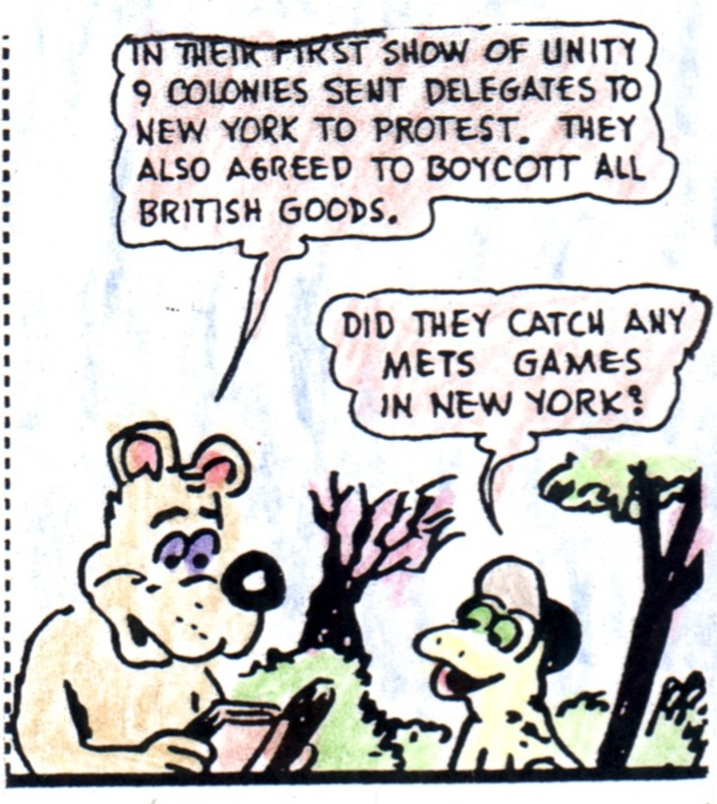
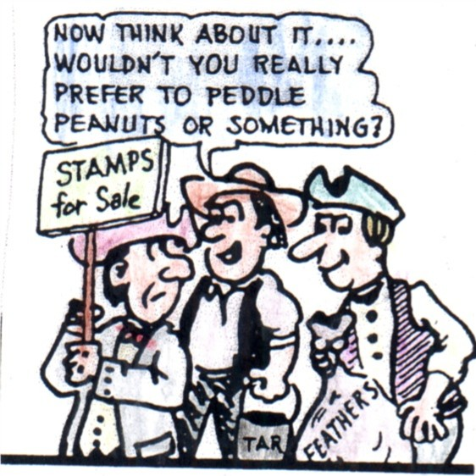
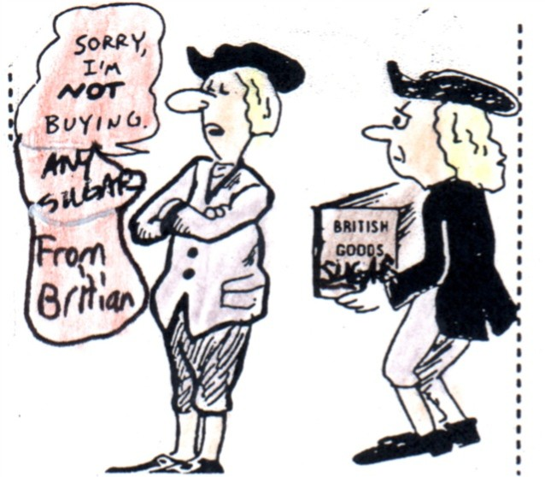
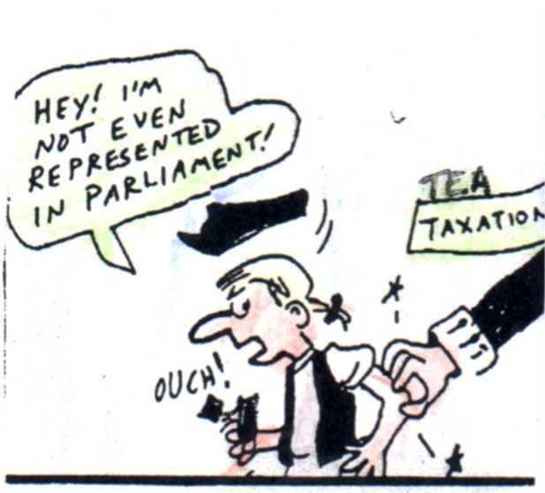

Proclamation of 1763 (1763)
Navigation Acts
(1650-1696)
British's
Acts
Sugar Act (1764)
Stamp Act Congress (Oct. 1765)
Declaratory Act (1766)
Townshend Acts (June 1767)
Boston Massacre (March 5, 1770)
Tea Act (1773)
Boston Tea Party (December 16,1773)
Intolerable Acts (Spring 1774)
1st Continental Congress (Sept. 1774)
Battle of Lexington and Concord (April 18, 1775)
2nd Continental Congress (May 1775)
Battle of Bunker Hill (Summer 1775)
Declaration of Independence (June 1776)
Their Marching
Towards a
A War of

for all

Freedom
Stamp Act (March 1765)
1650 |  | 1763 | 1764 | 1765 | 1766 | 1767 | 1768 | 1769 | 1770 | 1771 | 1772 | 1773 | 1774 | 1775 | 1776

Tea
Lex and Concord
Bunker Hill
Boston Mass
ichael Plasmeier

