ichael Plasmeier
Meisser
PD 6
XY
Marlin
Definitions

- Cells: The basic units or building blocks of life.
- Fertilization: The joining together of a female egg cell with a male sperm cell.

- Uterus: A pear-shaped organ in which a baby grows and develops till a baby is ready to be born.
- Embryo: A developing organism from the time of fertilization till about the 8th week of development.
- Placenta: A thick, rich tissue that lines the wall of the uterus during pregnancy and nourishes the fetus.
- Umbilical cord: A tube that connects the fetus to the mother’s placenta.
Answers

- When an egg becomes a zygote: When it is fertilized.
- When the zygote becomes a blastocyst: When a fluid-filled cavity forms in the center.
- When implantation occurs: 6-7 days after fertilization.
- When the growing organism is known as an embryo: When fertilization occurs till about 8 weeks.
- When an embryo becomes a fetus: At 8 weeks after fertilization.
- Status: Monthly

- Heart beats after 3.5 weeks.
- Some brain waves evident.
- Bone marrow rakes red blood cells.
- Fetus can suck thumb.
- Fingernails grow.
- Can cry and kick
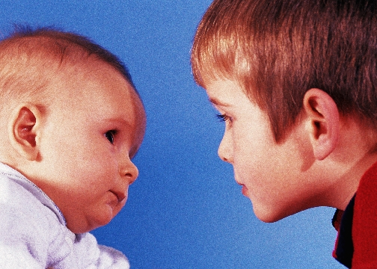
- Eyelids open.
- Hair starts growing
- Birth!
Stages: Labor

Dilation of the Cervix:
- Cervix expands and opens dilates
- Contractions start and become more frequent

Delivery of the Baby:
- Baby drops down birth canal
- Mother pushes baby out
- Umbilical cord is cut
- Contractions continue

Delivery of the Placenta:
- Placenta of the afterbirth is expelled
- Uterus contracts to cut off blood vessels.

