Michael Plasmeier
7/31/2026
P.D.:2

The American Revolution Rebus

“The shot heard ‘round the world”, started which would become a 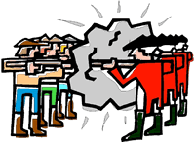. A that would be the first of it’s time. A for independence. The want independence from their mother country, . was not happy.

This starts with the 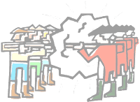 of Lexington and Concord. The wanted to take away the 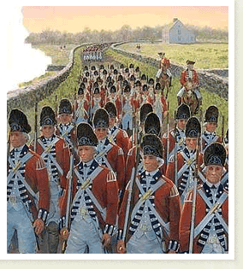’s 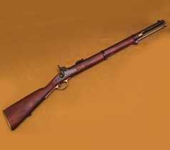. Paul Revere warned the , and they did pretty well against the . The , led by Tomas Gage, then went on to Concord, where they burned the town. The stopped them.

The next took place on Bunker Hill and Breed’s Hill. The were outnumbered, and they suffered only 400 dead, the , 1000. , and 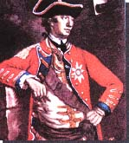, won after a long day of , when the , and Israel Putnam, their general, ran out of .

The Declaration of Independence, was signed by the Second Continental Congress, and the began for real. The then made a really bad mistake by trying to take 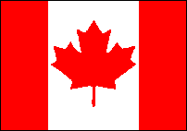, in the battle of Quebec and Montreal. Richard Montgomery and Benedict Arnold, lead their troops to -controlled , where they made a series of mistake. The were too strong, and the weather was too cold. won, hands down. was forced to retreat, and the just escaped with their lives. But, they lived to fight again.

The leader, 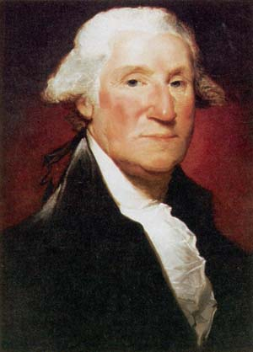, moved his new group of to New York. , moved in and greatly outnumbered ’s in New York. had to use all of his skill to move the out of town, in the middle of the night, under a heavy cloud off fog. Still it could have been a whole lot worse.

In Trenton, on Christmas, 1776, crossed the Delaware River, and some of his marched all the way without shoes to Trenton. It was there that they surprised the Hessian (hired soldiers) who were all drunk and playing cards on this holiday eve, instead of on alert. The Hessian general was Colener Johann Rall. won the battle and did not loose even one man. They captured lots of much needed , and they were in Princeton, where they also won, on January 2nd.

decided to Philadelphia, on his way to Albany. raced to stop him. They met at Brandywine Creek, and ed. Howe’s troops massacred the . He could have wiped out the entire Continental , but he didn’t. This was very lucky for the

then continued to Albany, where he expected to meet up with all the other , who didn’t show up. He was far outnumbered and surrounded by General Horatio Gates and other . Benedict Arnolds led a charge, and forced their entire to surrender. This was a major turning point, as it showed our allies that we might win, and that the are able to be beat.

Next up is a inspirational 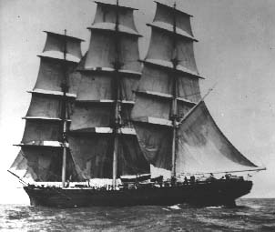 . It did not provide a major advantage to any side, but it showed the determination. Experienced 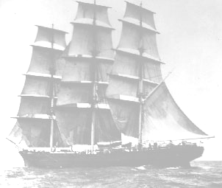 captain, John Paul Jones, led a called the Bonhomme Richard. It was up against the strongest in the world, the navy. Jones’s met up with the Serapis, as it continued the ’s mission, to cut off supply . The was not going well for Jones, as two of his were immediately disabled. He then came back from behind to win the . His was so badly damaged that it had to be abandoned, after they won the .

then turned their attention to the south, where they next. Things were not going well for the down south. was winning after , taking cities down one after another. This charge was led by leader, Henry Clinton. Horatio Gates, the leader, was making bad decisions, like feeding the something that would make them sick, and wanting the to fight after a long, grueling march. The then turned to guerrilla warfare, where hid behind trees and shot, instead of being in long orderly rows, like the , and other traditional European countries.

In Yorktown, Marquis de Lafayette met general Charles Cornwallis, who held the island. realized a chance, and sent down Comte de Rochambeau, a French general, with to surround Yorktown. For weeks Cornwallis stayed on the island, and tried to fend off the advancing . After a while, Cornwallis surrendered. The war was won for the !

All the war, all that was left was to form up all the details formally. The Treaty of Paris was signed in 1783, and stated that: was independent from ; the country was expanded out to the Mississippi River, and down to the 31st parallel; and that the troops would leave, and go home. could also can keep . The war was over; was free!

Key:
= America / Colonists
= British
= Canada
= Battle / Fighting
= War
= Navy / Ships (Plural)
= Ship
= Gun[s] / Ammunition / Cannons
= Troops / Army / Minutemen
= William Howe, British General
= George Washington, American General
= Big

