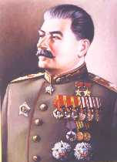
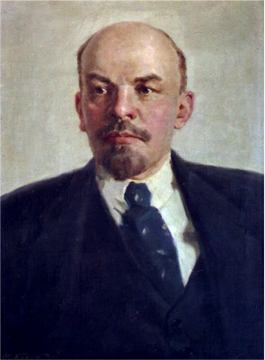
Russian Revolution Project: “Teacher for a Day”
Big Ideas: (a.) Decisions made by leaders determine their cycle of power.
(b.) Dissatisfaction with the current structure of society can lead to political, social, and economic change.
(c.) Leaders hold world views that can influence the social, political, and economic direction of a society.

Objective: In groups, teach a lesson on the major themes and events leading to, during, and after the Russian Revolution.

What each group will do: Each group will be assigned a topic to research, synthesize, and eventually present to the class. All groups will:
- Instruct the class for 10 minutes about your topic
- Create a 2 – 2 ½ page outline to be distributed to the class on the presentation day.
- Each group will create a practice worksheet with questions for the class to complete after the instructional time. All questions should be included in the material presented to the class and the outline.
- Create a lesson plan diagramming and explaining the main ideas, activities, and roles for each group member during the presentation/lesson.
- Have an additional method of presenting the information to the class outside of lecture. Groups can lecture as a method during the presentation, but must also utilize another approach (PowerPoint, Trifold/Poster w/ big writing, music, skit, video, or other ideas with pre-approval by Mr. Smith first). If your group uses PowerPoint, it cannot be the only method of teaching you use during your presentation. It can only be PART of the presentation.
- All group members must be involved an equal amount of time. All members must also know the material so that they are not reading. Make it interesting!!!

Work time/Due Date: Work Days: 5/24/06 and 5/26/06. Presentations: 5/31/06
Topics and Page Numbers:
- Life Before the Revolution
  - Hand out from the old textbook (packet) p. 641-645
  - New textbook p.389-390 up to and not including “The Revolutionary Movement Grows”

- Revolutionary Conditions, Groups, and 4 Mistakes of Czar Nicholas II
  - Hand out from the old textbook (packet) p. 646- 648 up to and not including “A nation in chaos”
  - New textbook p.390-391 up to and not including “The March Revolution”

- March Revolution, Czar Nicholas II abdicates, Lenin and the Bolsheviks
  - Hand out from old textbook (packet) p. 640-641 up to and not including “Russia struggled to reform”, p. 648-652 up to and not including “Civil war divided Russia”
  - New textbook p.391 beginning with “March Revolution” up to and not including “Civil War Rages in Russia” on page 393

- Civil War in Russia, Lenin Restores Order, and Totalitarianism in Russia: Joseph Stalin
  - Hand out from old textbook (packet) p. 652-657
  - New textbook p. 394-398

Other Important Information: Make sure you let me know if you need to use a stereo, Power Point, overhead projector or any other device the class period BEFORE your presentation. This is your opportunity to be a teacher for a day…so make it interesting!!! Make sure your group covers all of the important information in your section, if you have any questions please ask!!!!

Scoring Guide for Russian Revolution Project

Presentation (50 points)
  - meets time requirement
  - all members involved equally
  - members know their information
  - Theme and significance of your topic is explained and presented to class (Why is your section important to the Russian Revolution?)
  - Connect to the “Big Ideas” for this project
  - information is presented so the class can hear and understand
  - Ready to present on due date

Outline/Worksheet (20 points)
  - All required information from the section included
  - Free from spelling and grammar errors
  - Questions are original questions created by the group
  - Typed
  - The questions/activities are in different forms (multiple choice, fill in, short answer, etc.) and are thoughtful (cause class to think)
  - Turned in on time

Accuracy of Information (20 points)
  - Information is correct and presented clearly to the class

Creativity (10 points)
  - Group has used a unique method to present the information to the class
  - More than one teaching method is used

Lesson Plan (15 points)
  - Diagrams and explains the main ideas
  - Activities and roles for each student are explained
  - Typed
  - At least one page, maximum 2 pages
  - Turned in one time TOTAL: 115 Points

