Electronic Voting Machines Implication Bungled
By Michael Plasmeier theplaz.com

Abstract
Electronic voting machines in the United States have experienced many vulnerabilities in the past years due to their rushed implementation. As a result of the 2000 election snafu, Congress made $3.9 billion available to counties to replace their old voting systems. Companies rushed in to provide solutions and get a piece of the money. The time allowed was not sufficient to properly create new machines. Instead, old code, produced for less secure purposes, was reused. This sloppy programming caused bugs and security vulnerabilities in the software.
The culture of the industry emphasizes secrecy. Code is created in secret. It is sent to independent testing agencies which have poor track records. Their reports are secret. Researchers and counties are threatened with lawsuits to prevent true independent investigations. No design documents or explanation of how the system works are published, even though some of the most secure computing systems we use are public knowledge.
In addition, the industry did not react appropriately to the security issues. In the past, the companies have tried to explain away their mistakes, instead of admitting issues. In addition, one group alleges that a company hired ghost writers to tarnish the reputations of activists. One activist election official was labeled as “irresponsible” and had trouble buying new equipment which causes him to be threatened with losing his jobs. At least one company is trying to spin-off its elections division because it is not worth keeping.
There are 10,071 different jurisdictions that conduct elections in the United States. Each has different procedures and rules. This has lead to mistakes. Such mistakes are known about for years, but were not clearly communicated and or understood by every county official.
It is essential to our democracy that we have an open and transparent voting system. Security is the absence of all insecurity. The public must continue to question elections and keep pressure on companies to fix and eliminate security flaws. Having the machines leave a paper trail greatly alleviates the problem.

Table of Contents
Introduction: The 2000 Presidential Election 3
Help America Vote Act 3
Diebold History: Cash up for Grabs 4
Hurtsi Hack: Negative Memory Cards 4
Recount Fraud in Cuyahoga 5
Payback Blacklist 6
Accuvote Flaws: Aviel Rubin 6
Engineering Practices 6
Smart Cards 7
GEMS Back Door Double Books Issues: Bev Harris and James March 8
Diebold Responds 8
Lawsuit 9
GEMS Deck 0 Issue: Humboldt County 9
Bad Communication 9
Faulty Logs 9
Log Deletion Button???? 10
Diebold Responds 10
Procedures 10
Rigging an election: Tuscan RTA Ballot Measure 11
Auditing Firms 11
Sequoia in New Jersey: Ed Felten and Andrew Appel 12
You Can’t Investigate Your Own Machines! 12
Seals 13
Rubin’s Day at the Polls 2008 13
Corporations 14
Companies Misrun 14
Misinformation 15
Partisan Corporation? 15
Bringing it All Together 15
Black Box 16
Solutions 16
Voter Verified Paper Trail 16
Instant Gratification 16
Centralization 16
Ballot Usability Design 17
Open Source: Less Vendor Control 17
Today: Are We Secure? 17
Diebold Says Yes 17
Vital to Democracy 18
Continued Vigilance 18
Works Cited 19

Introduction: The 2000 Presidential Election
The 2000 presidential election was historic; a national election, with over 100 million voters, came down to a few thousand votes in Florida (Levine US News). During the months that followed the election there was an intense scrutiny of the voting process and the flaws of the system. Two of the main flaws identified were butterfly ballots and hanging chads. Butterfly ballots put half of the candidates on each side and have an area to punch the votes down the middle with a metal stylus. The stylus makes a hole in the ballot; the paper that falls off is called a chad.
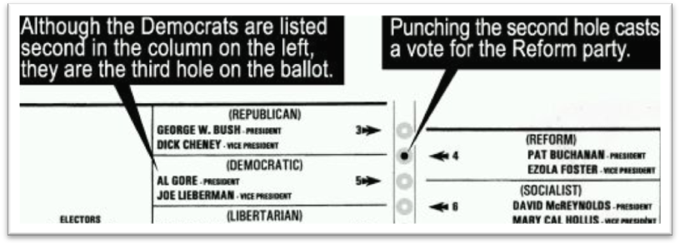
Some experts think that many Gore voters may have accidently voted for Reform candidate Pat Buchanan (Jerz). Buchanan received 3,407 votes in the heavily Democratic district, which is far more votes than he (a conservative, former Republican) had received in some far less liberal districts (Jerz). Many Democrats found this unfair. Another usability issue was that 19,000 ballots in Palm Beach were thrown out because people voted twice; some no doubt believing that they needed to also vote for the vice president (Jerz).
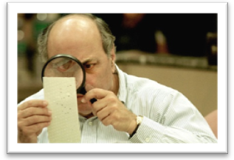
Sometimes the chad did not come off all of the way; this is called a hanging chad. Election officials had to attempt to determine the intent of the voter (Levine). However, first they had to decide what would count as voter intent; would hanging, dimpled, or pregnant chads be counted (Levine)? The Supreme Court actually ruled to stop the recounts because the Constitution guaranteed equal protection for all citizens (Levine). They disqualified a manual recount since different standards were being used in different counties (Levine).

Help America Vote Act
As a result of this mess, Congress implemented the Help America Vote Act in 2002 (PL 107–252). Congress established a program to provide funds to states to replace punch card and lever voting system (PL 107–252 summary). Congress and the public wanted to insure that what happened in Florida could never happen again. In order to qualify for the money, states had to have replaced their old systems by the 2004 election (PL 107–252 §102 a3A).
A Florida election official tries to divine a voter's intentions. (Robert King/Newsmakers/Getty Images)
In the race to implement electronic voting machines, the implementation was horribly bungled. Electronic voting machines do prevent recounts from happening. But they do so, by not allowing recounts at all! The number which the machine totals must be trusted! This is very scary because there are many signs of poor programming ranging from silly to serious. One flawed machine randomly deleted votes. If one assumes the possibility for malicious intent, many machines are easily vulnerable to tampering, without any evidence being left. Other machines have security features so poorly implemented; they provide only minor speed bumps to attackers. These issues have been identified in machines made by various manufactures and in various different designs.

Diebold History: Cash up for Grabs
Diebold is the company most associated with electronic voting machine insecurity. In 2000, Diebold was a $3 billion company primarily involved with the sale of ATMs (Gimbel Fortune). There was not much money in election systems; municipalities were using the same old systems for decades. That all changed when the Help America Vote Act made $3.9 billion available to states to replace their own machines (Gimbel Fortune). In 2001, Diebold entered the market by buying Global Electronic Systems, based in McKinney, Texas, for about $30 million (Gimbel Fortune). Their touch screen electronic voting machine was not a big seller (Gimbel Fortune). Global had purchased the technology from a small company called I-Mark, where it had been designed as an unattended voting terminal that could be used in places like shopping malls or supermarkets (Gimbel Fortune). Diebold has since changed their name to Premier; however this paper will continue to refer to Diebold by its most well-known name.

Hurtsi Hack: Negative Memory Cards
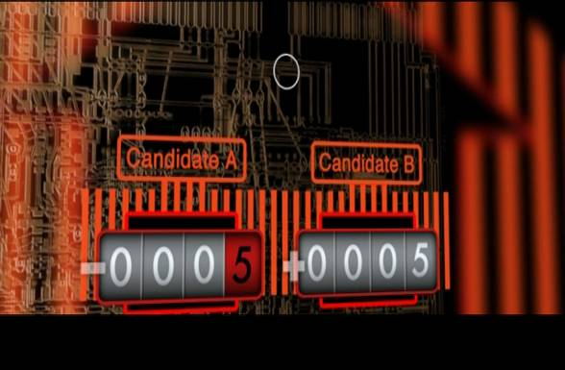
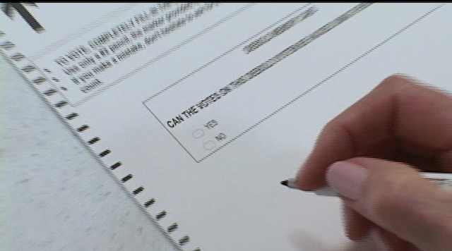
In 2005, Ion Sancho, Supervisor of Elections in Leon County, allowed computer security expert Harri Hursti along with Bev Harris and others to conduct a hack on a Diebold Accu-Vote OS 1.94w optical scan machine. With an optical scan system, a voter fills out a ballot on paper and then feeds it into an optical scan machine. The machine counts the ballots and records the totals onto a memory card (Hacking Democracy 1:15:00). Illogically, the memory card supports having negative votes. Hursti was able to rig a mock election by modifying the memory card to have the “no” vote on a ballot question start with -5 votes and the “yes” vote to start with 5 votes already entered (Hacking Democracy 1:09:40).
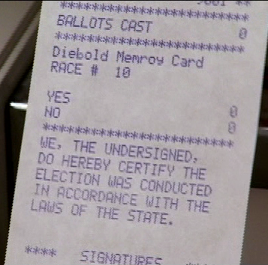
When a memory card is inserted into the machine, the machine prints out a “zero tape” which shows that there are no votes on the card (Hacking Democracy 1:14:05). The machine printed out a zero tape even for the modified memory card (Hacking Democracy 1:14:17)! The mock voters then recorded their vote on paper ballots and scanned them through the machine. The “no” vote increased the count through 0 into positive territory (Hacking Democracy 1:09:50).
Question | “Yes” | “No” | Total Votes
Memory Card Set | 5 | -5 | 0
“Zero Tape” | 0 | 0 | 0
Actual Ballots | 2 | 6 | 8
Machine Total | 7 | 1 | 8
This is similar to the traditional “stuffing of the ballot box.” With traditional stuffing, however, you find that there are more ballots than voters. Hurtsi’s hack does not have this problem. The total number of votes reported by the machine equals the real number of voters! After witnessing the hack, Sancho could not believe it. He stated that “if I had not seen what was behind this, I would have certified this as a true and accurate result of a vote” (Hacking Democracy 1:16:50).
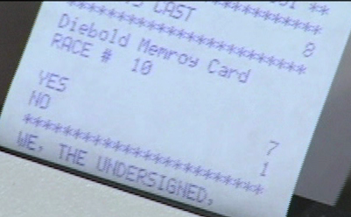
In response, Diebold claimed that only authorized persons should test their machines for security (Hacking Democracy 1:19:10). Diebold lawyers called Sancho’s hack “a very foolish and irresponsible act” (Goldfarb Washington Post). Apparently county directors of elections are not allowed to test their own machines which they purchased. Diebold claims that the hack is similar to leaving a car’s keys in the ignition and the windows down (Hacking Democracy 1:19:10). But why then, did the machine print an incorrect “zero tape”? And why does the memory card use signed integers (allowing negative numbers), instead of unsigned integers? Scientists at Berkeley University confirmed the Hursti Hack and found 16 more security flaws (Hacking Democracy 1:19:40). However, Sancho is lucky that he uses optical scan ballots, which can be manually recounted if needed.

Recount Fraud in Cuyahoga
However, a recount is not infallible either. Recently, 2 Cuyahoga County election officials plead “no contest” to charges that they rigged a recount in Ohio (AP). Ohio law called for a random 3% recount (Hacking Democracy 55:09). However, the officials selected the ballots to recount in order to save themselves a lot of work (AP). Although this election used punch cards, it shows that election officials cannot always be trusted to run proper recounts.

Payback Blacklist
The Nation calls Sancho, “one of the few election supervisors who actually takes his job and his civic responsibility seriously” (Gumbel). However, the companies struck back against Sancho. A few years after he publicized the vulnerabilities, he needed to purchase touch-screen machines to meet the Help American Vote Act requirement that at least one machine per precinct allow disabled voters to vote independently (Gumbel The Nation). All 3 of the companies certified in Florida refused to sell him machines, and state officials threatened to fire him if he did not comply with the law (Gumbel The Nation). Sancho was put on a black list because as he put it, he was “a walking and talking contradiction of what [the voting-machine companies] have been attempting to spin about the integrity of their systems” (qtd. in Gumbel The Nation). In the end, with support from the electorate, newspapers, and Attorney General Charlie Crist, he was able to purchase enough Diebold machines (Gumbel The Nation).
Sancho still uses Diebold machines in Leon County. However, he takes the extra precautions that he is allowed to take by law. He does not allow “sleepovers;” machines are delivered on election morning (Sancho qtd. in Friedman Video Interview 2:28). They are never left unattended so that no one can make unauthorized modifications. In addition, due to the publicity of the fights he went through, almost no one uses the touch screen machines (Sancho qtd. in Friedman Video Interview 6:22).

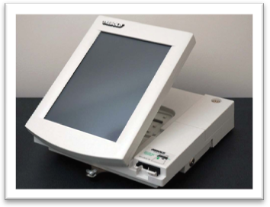
Accuvote Flaws: Aviel Rubin
In 2004, Aviel Rubin, professor at the Information Security Institute at Johns Hopkins University, conducted a thorough review of the Diebold AccuVote-TS voting machine source code version 4.3.1 which was leaked online. The AccuVote-TS is a modern computer that runs Windows CE and has a full video display with touch screen. Their analysis showed “that [the Diebold AccuVote-TS voting system running source code version 4.3.1] is far below even the most minimal security standards applicable in other contexts” (Rubin et al. 1). They found that, “without any insider privileges, [an attacker] can cast unlimited votes without being detected by any mechanisms within the voting terminal software” (Rubin et al. 1). This paper will only cover selected vulnerabilities in limited detail.

Engineering Practices
First, Rubin and his team accused Diebold of not having sound software engineering processes. In the leaked code, they did not see any references to design documents or defect repositories (19). These are vital to coordinating the production of high quality software. In addition, the level of care and commenting on the code was uneven, with some sections dating back to 1996 (18). This is not surprising giving Diebold’s history and the code’s legacy. Security professor at the University of Iowa, Douglas Jones, thinks that Diebold should have just started over (qtd. in Gimbel Fortune). But they could not, since they had to sell the machines in order to beat their competitors and make the deadline.
Other sections are marked by a programmer that he or she is not happy with the code; “this is a bit of a hack for now” (20). Rubin later said that "It looked like an experimental student project; if it was my student's project; they would have gotten an F" (qtd. in Gimbel Fortune). Diebold contents that they follow commonly accepted software development practices and that the code was in development (Diebold “Checks and Balances” 27). Rubin retorts that election software should follow a more security-focused development methodology by following Department of Defense specifications oriented towards producing secure code (“Rebuttal”). In addition, Diebold claims that it has put new development methodologies into place since the report; however, no methodologies or design documents have ever been disclosed. When contacted by the author, Diebold stated that they have “strengthened [their] products” and that they “are working on next generation hardware and software that has even more robust security features” (Riggall/Diebold E-Mail).

Smart Cards
This particular model of Diebold machine uses smart cards to authorize voters. After checking in at the polls, a voter is handed a smart card. This card is used to activate the voting machine. After a vote is cast, the machine cancels the card, and the voter returns it to officials on the way out. Rubin contends that a sophisticated outsider is able to make either unlimited copies of the smart card, or a card that is unable to be canceled (10). He contends that smart card equipment and programming knowhow is cheaply available on the internet (9). An attacker can either figure out the smart code protocol by inspecting the leaked source code, or installing a “wiretap” device between the machine and the genuine smart card (9). If the machine were to properly authenticate the smart cards with cryptography, neither of these attacks would work, even if the attacker had perfect knowledge of the system, including the source code (9).
Diebold believes that their smart cards are special and not available to the public (8). However, Rubin explains that homebrew smart cards can be programmed by using a completely programmable card, such as a “Java Card” (“Rebuttal”). Diebold retorts that this cannot be called “easy” (8). However, people already spend millions of dollars to influence elections – the possibility that an organization or foreign government is interested in affecting our elections is too large to ignore.
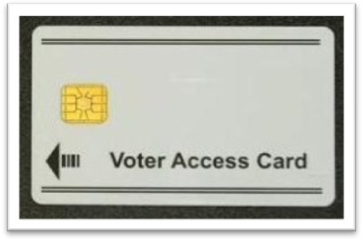
Assuming that these cards can be made, Diebold believes that if more votes are cast than electors who checked in, a red flag will go up (9). This is most likely true. However, they have hit on the big flaw with electronic voting machines. How would that election be resolved? All they would have is a printout from each machine with the total votes cast. Election officials would know they have an issue, but have no way to determine which votes are legitimate. This would cast serious doubt on an election. If the election is close, like it was in Florida, there would be a similar controversy, but without any ability to conduct recounts. Older lever machines also seem to have this problem, but such systems use other ways to make sure only one vote is cast, for example, mechanically opening the curtain after a vote is cast; they do not rely on smart cards or technology to make sure only one vote is cast.

GEMS Back Door Double Books Issues: Bev Harris and James March
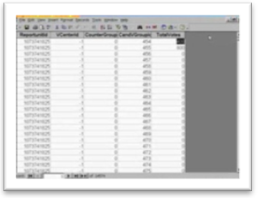
In 2003, James March and Bev Harris discovered a large vulnerability in Diebold’s GEMS central tabulating software. This is important because as William "Boss" Tweed, who effectively ran New York City in the mid-1800s, once noted, "the ballots made no result; the counters made the result" (qtd. in Gimbel Fortune). The GEMS system counts the result for both touch screen and optical ballot Diebold machines.
The GEMS system did have a global password for all users and logged most changes made in the software (March GEMS Tabulator Video). One relatively minor issue was that the log did not differentiate between users because everyone used the same account (March GEMS Tabulator Video). The big problem is that GEMS’ data is stored in a plain Microsoft Access file which may be edited by anyone with physical access to the computer. It is a backdoor into the data. No password is needed, and changes are not logged (March GEMS Tabulator Video). This would allow a janitor, if the computer is left on during the night, to change results without leaving a log trail (March GEMS Tabulator Video). What’s more, the attacker would have full access to change the log in any way (March GEMS Tabulator Video).
In addition, the system stores precinct tallies in two separate database tables (March GEMS Tabulator Video). If an attacker changed results in one of the tables, the change would only appear on the county wide total (March GEMS Tabulator Video). It would not appear on precinct-by-precinct reports (March GEMS Tabulator Video). That means that even if a manual recount was completed on a precinct, it would appear correct. But the county results would still be incorrect. They could only be verified by manually adding all of the precinct totals. Most officials would assume that a computer is more than able to total precinct counts and would not investigate it.

Diebold Responds
Diebold claimed that all allegations are false (“GEMS Cannot be Hacked”). Diebold contends that the two tables design follows normal database design specifications (“GEMS Cannot be Hacked”). However, the tables should be cross checked when printing reports. Finally, why can individuals just open the tables in Microsoft Access? There are ways to encrypt the entire database so that only a user with a password could open it. At press time, Diebold claims that the database is encrypted in the latest version of GEMS (Riggall/Diebold E-Mail).

Lawsuit
In July 2004, Bev Harris and James March filed a "Qui-Tam" lawsuit against Diebold on behalf of the state of California (Scoop). A Qui-Tam lawsuit is a suit brought by a whistleblower in order to recover damages for the state. In November, the suit was settled; Diebold agreed to pay a $2.6 million settlement (Lucas SF Chronicle). Thomas W. Swidarski of Diebold said that they believed they had a “strong response” to Harris’s claims but settled in order to “build an effective and trusting relationship with California election officials” so that they can continue to “work together in building election solutions that address the state's needs” (Lucas SF Chronicle).

GEMS Deck 0 Issue: Humboldt County
The main response that Diebold uses for anyone that questions their systems is that Diebold machines exist in the larger context of an election (2). Polling officials are supposed to follow strict procedures. However, following procedures did not save Humboldt County in the 2008 election from a tabulating error cause by a known flaw in Diebold GEMS voting system 1.18.19 (Zetter Threat Level). Humboldt County used optical scans ballots which are scanned and counted in the GEMS system.
The issue was not discovered through their standard canvassing procedures, which requires 1% of only in-person ballots to be manually recounted (Zetter Threat Level). The ballots missed were mail-in ballots, which did not need to be recounted (Zetter Threat Level). The issue was discovered through their Transparency Project, where they independently scanned all of their ballots on a commercial scanner and posted them online for people to review (Zetter Threat Level). Citizens discovered that 197 ballots from the city of Eureka were not counted. Diebold investigated the issue and discovered that Humboldt had run into the Deck 0 problem (Zetter Threat Level). Because of Diebold’s programming error, the first batch (“deck”) of ballots can sometimes be randomly deleted if any subsequent deck is deleted (Zetter Threat Level).

Bad Communication
Diebold knew about the issue since 2004 (CA Secretary of State “Official Report” 2). At that time, they informed the current Humboldt County director of elections; however, the director never recorded the workaround in the county procedures and subsequently quit his job (Zetter Threat Level). Thus, the current director had no knowledge that the flaw existed and that a workaround needed to be performed. The notification also did not inform officials that failing to follow their workaround would result in the deletion of votes without any notice or why the new procedures were needed (CA Secretary of State “Official Report” 4).

Faulty Logs
The log also did not perform correctly. The Secretary of State’s investigation showed that the GEMS system failed to record when decks were deleted, including the decks elections staff deleted on purpose in order to rescan (7)! Some date and time stamps were found to be wrong (CA Secretary of State “Official Report” 7). In addition, there was no record of a deck 0 ever being scanned, but there was a record of it being scanned in a backup from before it was mysteriously deleted (Zetter Threat Level). This suggests that it is not a log, but a reconstruction of what it thinks is correct. That would be outright fraudulent.

Log Deletion Button????
In addition, the log had a delete button (CA Secretary of State “Official Report” 7). This violated the Federal Election Commission’s 1990 Performance And Test Standards For Punchcard, Marksense, And Direct Recording Electronic Voting Systems (“1990 VSS”) which requires that machines provide “a concrete, indestructible archival record of all system activity related to the vote tally.” The button destroys the audit logs without any confirmation or warning (CA Secretary of State “Official Report” 10). The Secretary of State reported that another elections official had accidently hit the “clear” button instead of the “print” button (11). Internal Diebold emails from 2001 show that Diebold knew it was a bad idea (CA Secretary of State “Official Report” 11). Somehow the button was added and made it past several levels of testing and certification.
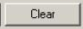
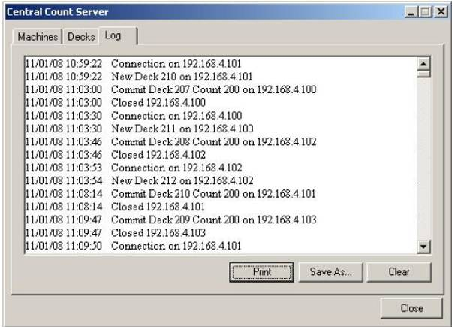

Diebold Responds
Diebold claims that the miscount “troubled [it] greatly” (Bales/Diebold 2). It also claims that it has implemented a “Product Advisory Notice” system to “memorialize” issues it sends to county officials (Bales/Diebold 3). Diebold did not fix the deck 0 problem until version 1.18.24, 5 versions later than what Humboldt County was using (Zetter Threat Level). The “clear” button was removed in version 1.18.20, but again counties continued to use old versions of the software (CA Secretary of State “Official Report” 7). Diebold promised to be more “aggressive” in the future to get counties to upgrade from buggy software, but Diebold cannot force counties to upgrade (Bales/Diebold 5, Riggall E-Mail).

Procedures
Even though Humboldt followed procedures, it is impossible to prevent all human mistakes. A system should be robust against these human factors. The problem is further compounded by the 10,071 different jurisdictions that conduct elections on a regular basis (Pew Center on the States 10). Each of these jurisdictions creates its procedures independently; as Humboldt showed, every county may not be able to keep up with the technology. It’s a recipe bound for disaster. The federal government investigates and audits banks, but not elections (Hacking Democracy 48:00).
In Hacking Democracy, volunteers discovered one county throwing away signed poll tapes, a violation of federal law (45:01). In another case, California sued another voting machine company, ES&S, for selling 972 uncertified machines to California counties (Weiss Computerworld). The law is not being consistently followed in all of the over 10,071 election districts in the United States; there is just too much that can go wrong with procedure.

Rigging an election: Tuscan RTA Ballot Measure
Diebold also claims that election officials help protect results (Diebold “GEMS Cannot be Hacked”). But what if the officials are crooked? These officials might just be trying to avoid work, like in Cuyahoga County, or they may actively try to rig an election. There recently was a criminal probe that conducted a manual recount in the 2006 Regional Transportation Authority ballot measure (Duffy Tuscan Citizen). The measure had failed 4 times and was losing in pre-election polls (March Election Defense Alliance). It was regarding a significant amount of money, $2.1 billion, and it reportedly passed with a 3-2 margin (RTA). It was alleged that a vote counter was discovered with a Microsoft Access user manual next to him (March Election Defense Alliance). The election officials refused to allow even basic inspections in the weeks after the election (March Election Defense Alliance). Key files were overwritten and time stamps do not add up (March Election Defense Alliance). In April 2009, 3 years after the original election, the Attorney General affirmed the result of the election and found no issues (Friedman).

Auditing Firms
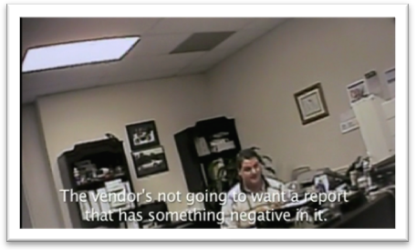
Another recurring theme of the electronic voting machine companies is that their machines are certified by testing companies (ITAs), as most states require. However, these firms do not provide much reassurance. First, the reports are secret. Second, some issues are not discovered and can live on for years, like the “clear” button in GEMS 1.18.19 (CA Secretary of State “Official Report” 8). Third, leaked reports show that security penetration was listed as “not tested” (Hacking Democracy 15:37). Shawn Sothworth, of CIBER, explained that all they test is compliance with FEC guidelines (Hacking Democracy 18:11). He said that they prepare the reports for the vendors and that “the vendor is not going to want a report that has something negative in it” (qtd. In Hacking Democracy 18:59). The CIBER offices in Huntsville, Al seem to be a small room with only 1 or 2 people working (Hacking Democracy 18:12). At the time, CIBER had tested 68.5% of voting machines used in the country (Richardson).
Shawn Southworth, CIBER, Huntsville, AL (Hacking Democracy 18:58)
In January 2007, CIBER was disaccredited due to a “shocking history of sloppy, incomplete and non-existent testing” (Richardson). In September 2006, an investigation by New York state found “glaring deficiencies in CIBER’s security testing of voting machines,” in part because “the security test plan did not specify any test methods or procedures for the majority of requirements” (qtd. in Richardson). This does not inspire confidence that the companies are doing everything possible to make sure that the machines are accurate.

Sequoia in New Jersey: Ed Felten and Andrew Appel

You Can’t Investigate Your Own Machines!
So if ITAs cannot be relied on, we must rely on truly independent university professors. However, when New Jersey state officials wanted to lend some of their Sequoia Advantage voting machines to Ed Felten and Andrew Appel, researchers at Princeton University, Sequoia threaten to sue the researchers and the state (McCullagh CNET). Sequoia claimed, in so many words, that their license agreement prevented the state allowing independent investigations of their software (McCullagh CNET).
Sequoia believes that since the ITAs have already certified their machines, these researchers do not need to conduct a review (McCullagh CNET). However, if Sequoia is confident of its products, it should welcome independent reviews to establish accuracy. Sequoia must have been afraid of a real investigation into the security of their machines. It should be noted that the researchers had previously published scathing reports of other electronic voting systems (McCullagh CNET). Thankfully Superior Court Judge Linda R. Feinberg allowed the review to go on under a protective order to protect Sequoia’s source code (Paul Ars Technica).

The Sequoia Advantage machine is one of the older electronic voting machines, on sale since 1988 (Appel). The ballot is printed on a large piece of paper which is put on top of a matrix of buttons and lights. A voter touches the printed paper to indicate their choice; this triggers the button under the paper and turns on a light to indicate that the vote is selected. A vote is recorded when a voter touches the vote button on lower right portion of the machine. The processor in the machine is a Z80 invented in 1976 (Appel Report 46).
The report was released in October 2008, 6 months after it was authorized (Appel Freedom to Tinker blog). It was also lightly redacted to remove trade secrets and code actually implementing the hack. Without diving deeply into the results, the report found vulnerabilities both similar and different to the Diebold vulnerabilities discussed above (Appel). It cited sloppy security and development practices as the cause of some of the vulnerabilities (Appel).

Seals
One of the key vulnerabilities that they discovered was that the processor or ROM can easily be replaced in 7 minutes (Appel Report 14). This means an attacker can completely reprogram a machine. Sequoia retorts that tamper evident seals would prevent that from happening. However, Appel shows in a video that he is able to remove screw cap seals, strap seals, and tamper-evident security seals in about 30 minutes and conduct the RAM chip hack (Seals). The night before an actual election, Appel witnessed voting machines sitting around unattended in a public area in front of a polling place (Report 28). Appel believed that he would have enough time to modify some of the machines (Report 28). If he was caught, he could claim to be an election official doing some last minute maintenance.
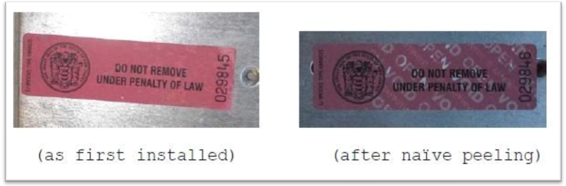

Rubin’s Day at the Polls 2008
Aviel Rubin, the researcher who wrote a paper on the Diebold issues, also had similar experiences with seals when he volunteered as a poll worker as he reported in his blog. In 2006 primary election, he reported that a “couple of times, due to issues we had with the machines, the chief judge removed the tamper tape and then put it back” (Rubin Blog). For example, a machine died when a voter was using it; Rubin said that “it occurred to me that instead of rebooting, someone could mess with the memory card and replace the tape, and we wouldn't have noticed” (Rubin Blog ‘06 Primary). In addition, it was hard to notice that the tape was removed; he could only notice a difference after some testing and “with great effort and concentration” (Rubin Blog ‘06 Primary). He believes that “the tamper tape does very little in the way of actual security, and that will be the case as long as it is used by lay poll workers, as opposed to CIA agents” (Rubin Blog ‘06 Primary).
In a later election, Diebold supplied the precinct he was working at with a representative (Rubin Blog ‘06 General). The man did not seem to know what he was doing. The representative said he was only hired yesterday and “had 6 hours of training yesterday. It was 80 people and 2 instructors, and none of us really knew what was going on. [Diebold is] too cheap to do this right. They should have a real tech person in each precinct, but that costs too much, so they go out and hire a bunch of contractors the day before the election, and they think that they can train us, but it's too compressed” (qtd. in Rubin Blog ‘06 Primary). In a later election, the representative “was not allowed to touch the machines” and “really did not have much to do” (Rubin Blog ‘06 General).
Many of his fellow judges knew Rubin was an election researcher and were careful to follow procedure around him (Rubin Blog ‘06 General). Rubin felt that the election he helped run ran smoothly (Rubin Blog ‘06 General). This was partly because the team often relied on him for technical help (Rubin Blog ’08 General). This was very helpful for that precinct, but not every precinct has a well-known expert on the machines. Other precincts are not that careful with procedures and do not have experts on the in and outs of the machines.

Corporations
Companies like Diebold are primarily motivated by profit. Ion Sancho, Supervisor of Elections in Leon County, says that “the vendors have entirely too much power” and that counties like his are “held hostage to financial desires of private interests” (Hacking Democracy 59:20).

Companies Misrun
According to Fortune magazine, Diebold has not been doing a particularly good job at making profits either. Fortune recently described Diebold like this:
Here's a five-step plan guaranteed to make an obscure company absolutely notorious:
First get into a business you don't understand, selling to customers who barely understand it either. Then roll out your product without adequate testing. Don't hire enough skilled people. When people notice problems, deny, obfuscate and ignore. Finally, blame your critics when it all blows up in your face. (Gimbel)
Diebold doesn’t run its books well either. In 2006, they were under “formal” investigation due to allegations of “misstatements to investors concerning projected revenue from voting machine sales and long-term service contracts” (Friedman Brad Blog). In May 2009, Diebold paid $25 million to settle the SEC investigation (Returns). The company in 2006 admitted to having made a "material overstatement of revenue and a material understatement of deferred revenue balances" for 2005 (Returns). In addition, in 2007, the company was defending itself in a Securities Fraud Class Action lawsuit charging fraud, insider trading, manipulation of stock prices, and concealment of known flaws in their voting machines (Friedman Brad Blog). The companies problems are catching up to it and causing Diebold to reevaluate being in the election systems business. Diebold is currently trying to offload the Premier Election Solutions (PESI) wholly owned subsidiary (2008 Diebold Annual Report 25).

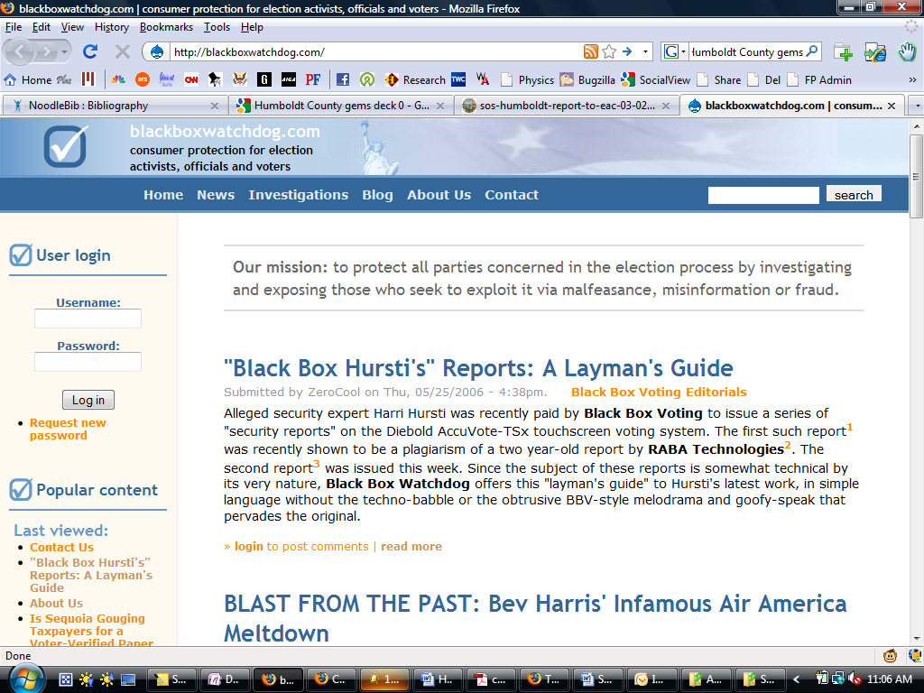
Misinformation
Voter advocacy group Black Box Voting.org did some traditional private-eye snooping and found that Diebold paid people to run websites supporting Diebold without identifying those sites as being funded by Diebold (“Diebold Persuasion Machine” 6). One site, blackboxwatchdog.com, reports that it is “not owned, operated by or associated with any other group, vendor or activist organization” (“About Us”) It claims that it “believe it's irresponsible to ambush vendors or their products in the media without attempting to work with them to resolve any problems first” (“About Us”). The site pounded critics of Diebold, including traditional reporters, to tarnish their creditability (“Diebold Persuasion Machine” 8). Black Box Voting.org linked the site to Rob Pelletier, an employee of Diebold (“Diebold Persuasion Machine” 13). Why should a company we trust to count our votes be involved with the undercover creation of false information?

Partisan Corporation?
In 2003, the Diebold CEO wrote in a private fund raising letter that he was “committed to helping Ohio deliver its electoral votes to the president [George W. Bush] next year [2004]” (qtd. in Smyth Cleveland Plain Dealer). This led some people to fear that company had changed their code to give Bush an advantage.

Bringing it All Together
Many flaws exist with electronic voting machines. These flaws include both innocent programming mistakes and vulnerabilities which can be used to attack an election. Voting machine companies point out that there have been no confirmed examples of people ever maliciously messing with electronic voting machines to manipulate an election. However, the poor programming techniques, which do not emphasize security, implemented in the rush to implement the Help America Vote Act underscores the fundamental flaw of electronic voting machines: the inability to audit or recount results. We have elections which hang on a few thousand votes or even a few hundred votes, out of millions. The potential for such a scenario is scary. Human factors, and procedure, as claimed by the voting companies are not infallible. Institutional knowledge changes and the stakes are certainly high enough for malicious poll workers to infiltrate our system. Voting machine companies seems to spend more time blocking independent audits of their machines and releasing carefully worded responses than actually fixing their code and owning up to problems.

Black Box
Even if the systems were well programmed, we still have black box voting. Votes are submitted into a counter which supposedly counts votes. The software running on these machines is not public and sometimes not even certified by state authorities (Lucas SF Chronicle). There is no way to verify the accuracy of an election. There is no recounting, no reifying, and no auditing. You must trust the number the machine gives.
The government should not have been so rushed to replace old voting machines with new untested machines after 2000. Better safeguards should have been in place as the machines were rolled out.

Solutions

Voter Verified Paper Trail
There are a few solutions to make electronic voting safer. Many have proposed voter verified paper audit trials (VVPAT). It is required to be used along with electronic voting machines in 31 states (Kibrick VoterVerified.org). About half of touch screens used today use a VVPAT (Gimbel Fortune). After a voter votes, the system print the vote onto a spool of receipt paper. The voter may then look at the paper and verify that it printed his vote correctly. When he or she believes that the paper is accurate, the paper advances to hide the vote. If irregularities arise, the printed spool can be manually counted. This effectively removes the black box aspect of the system. However, the system is not infallible. It can run out of paper or jam; but at least it provides an audit trail. In addition, Aviel Rubin thinks that VVPAT is too complex and expensive (Blog Congressional Hearing). He thinks that optical scan ballots are “economically viable and readily available” (Blog Congressional Hearing).
Diebold Elections System AccuVote-TSx DRE voting machine with a VVPAT attachment
http://commons.wikimedia.org/wiki/File:Desi_accuvote-tsx_vvpat.jpg

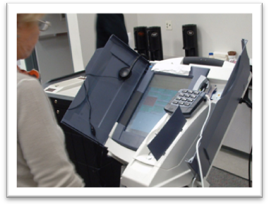
Instant Gratification
In the United States, election officials are expected to release results within hours of the polls closing (Sancho qtd. in Friedman Video Interview 4:30). This emphasis on speed over accuracy is wrong. Results should not be published until a few days after the election, when officials have ensured that everything is correct.

Centralization
10,071 jurisdictions administer elections independently (Pew Center on the States 10). The federal government does try to implement rules, but these are not looked favorably on by election officials. Many of the guidelines are voluntary. The Election Assistance Committee’s name is illustrative of the issue; their main role is to provide assistance. Some have proposed more centralized control; however that is beyond the scope of this paper.

Ballot Usability Design

Ballots should be designed by usability professionals. The American Institute of Graphic Arts (AIGA) created ballot design guidelines in conjunction with the National Institute of Standards and Technology (NIST) and the U.S. Election Assistance Commission (EAC). These guidelines spell out line by line, pixel by pixel how ballots should be best designed to reduce confusion. However, these guidelines are voluntary.
Ease of use of electronic machines is one of the advantages of touch screens (Rubin “Congressional Hearing”). Better designed scanned paper ballots, combined with advanced scanning machines which can detect under and over voting can rival the usability of touch screen voting machines (Rubin “Congressional Hearing”).

Open Source: Less Vendor Control
“I think we as election officials need to be more demanding to the vendors as to the technical specifications of this equipment,” Ion Sancho (Hacking Democracy 1:18:40). First, the companies should not have so much power to secretly create the systems. The systems should be open for inspection by anyone. Systems which are open are no less insecure; in fact, they can be more secure. The popular browser Firefox is open source. Anyone can look at the source and suggest modifications. As a result, many people consider Firefox to be one of the safest, more secure browsers. “Security by obscurity” has been called by security experts as “no security at all” (Gibson). The SSL protocol is used by millions of people every day to securely conduct transactions online. The system design, standards, and code are all public knowledge, but it still is secure. If the code to electronic voting machines was visible to the public, the companies would be held accountable to create secure, high-quality code. They would not rely on false security by keeping the code private.

Today: Are We Secure?

Diebold Says Yes
For its part, Diebold has been increasingly upfront about issues that are discovered. Spokesman Chris Riggall claims that the company is and will continue to be “open and forthright” when issues “come to light” (E-Mail). He correctly points out that no system can be completely secure, because security is the absence of all security (E-Mail). Riggall points out that many of the election systems we used before also had flaws, and that elections conducted without technology in developing countries are extremely inaccurate (E-Mail). Punch cards and optical scan ballots have been counted by computer since the 1960s and no one really complained (Riggall E-Mail). Riggall points out that the concern only started when they put a computer in front of a voter (E-Mail). Finally, the added public scrutiny helps to make the system better. As Chris Riggall puts it, “Our public concern and aspiration for security has grown immensely, but the systems in use, and the procedural safeguards that jurisdictions use, are far more robust than 10 or 20 years ago” (E-Mail).

Vital to Democracy
Our democracy is based on the right to self-govern. “The public is sovereign over the instruments of government it has created” (Harris E-mail). We maintain control over government by voting. For us to have control, we, the public, must know that our votes actually count. The public needs to be able to make sure that elections are accurate. They must be able to audit and independently verify results. The Transparency Project in Humboldt is a good example of this. It caught the Deck 0 error in the Diebold GEMS optical scan counting system. We cannot control the government if we cannot see what is going on.

Continued Vigilance
So we must maintain continued vigilance. It is because the non-partisan activists have investigated these flaws and stood up to lawsuits, intimidation, and personal attacks that we know as much about the system as we do. Almost all of the information discussed in this paper had either been leaked or discovered via a lawsuit. The companies continue to claim that their code must remain a secret.
Yes, many of the flaws addressed in this paper have been fixed. However, the same flawed process and secrecy remains. We cannot be sure that the system is without flaws. VVPATs and optical scan ballots provide a way to recount and audit results. Yes there were problems with the old machines; but our goal should not be to merely match the accuracy of the old machines, but to surpass them and to use the most secure and accurate machines we possibly can. Perfect security is the absence of all insecurities. Instead of blocking researchers, companies should be committed to conducting the most secure elections possible. Researchers, the government, and industry should work together to eliminate one-by-one as many insecurities as possible. But these are not fool proof either. Ultimately we must place our faith and our democracy in the system.
Works Cited
AIGA Design for Democracy. Ballot and Election Design. 2007. American Institute of Graphic Arts. 12 May 2009 <http://www.aiga.org/‌content.cfm/‌election-project>. AIGA created guidelines for ballot design from 2005-2007 in conjunction with the National Institute of Standards and Technology and the U.S. Election Assistance Commission.
AP. “2 Plead No Contest in Ohio Recount Case.” San Francisco Chronicle 5 Nov. 2007. 11 May 2009 <http://www.sfgate.com/‌cgi-bin/‌article.cgi?f=/‌n/‌a/‌2007/‌11/‌05/‌national/‌a162946S04.DTL&type=politics>. Article that election officials rigged the recount in Cuyahoga County.
Appel, Andrew. Insecurities and Inaccuracies of the Sequoia AVC Advantage 9.00H DRE Voting Machine. Center for Information Technology Policy, Princeton University. 6 May 2009 <http://coblitz.codeen.org/‌citp.princeton.edu/‌voting/‌advantage/‌expert-redacted.pdf>. The Appel (Princeton) report which shows flaws in Sequoia machines. It was redacted by the court to remove trade secrets and vulnerability details.
- - -. “Report on the Sequioa AVC Advantage.” Freedom to Tinker. 17 Oct. 2008. 6 May 2009 <http://freedom-to-tinker.com/‌blog/‌appel/‌report-sequioa-avc-advantage>. Abstract and announcement of the Princeton review of Sequoia voting machines.
- - -. Security Seals on AVC Advantage Voting Machines are Easily Defeated. Dec. 2008. 6 May 2009 <http://citp.princeton.edu/‌voting/‌advantage/‌seals/>. Appel shows that Sequoia security seals are easily removable in a report and video.
Black Box Voting.org, et al. The Diebold Persuasion Machine. 11 May 2009 <http://www.blackboxvoting.org/‌diebold-PRmachine.pdf>. Black Box Voting.org’s private eye investigation of Diebold’s PR efforts.
Bostrom, Parke, and Brad Friedman. “Disclosed: Diebold/‌Premier’s Humboldt County Termination Letters.” The Brad Blog. 30 Apr. 2009. 8 May 2009 <http://www.bradblog.com/‌?p=7109>. Article explaining Diebold has terminated its contract with Humboldt County.
Bowen, Debra, Secretary of State. California Secretary of State Debra Bowen’s Report to the Election Assistance Commission Concerning Errors and Deficiencies in Diebold/Premier GEMS Version 1.18.19. 2 Mar. 2009. Office of Voting Systems Technology Assessment. 14 May 2009 <http://www.sos.ca.gov/elections/voting_systems/sos-humboldt-report-to-eac-03-02-09.pdf>. Official report on the Humboldt Deck 0 issue.
Diebold. “Checks and Balances: Avi Rubin Response.” Diebold. 30 July 2003. 4 May 2009 <http://web.archive.org/‌web/‌20060526215215/‌http://www2.diebold.com/‌checksandbalances.pdf>. Archived response from Diebold going point-by-point through Avi’s analysis and refuting select claims.
- - -. The GEMS System Can Not be hacked. 2006. 6 May 2009 <http://web.archive.org/‌web/‌20060701023934/‌http://www.diebold.com/‌dieboldes/‌pdf/‌rebuttal.pdf>. Diebold’s rebuttal to Bev Harris’ GEMS hack.
- - -. Statement of Justin Bales, Western Service General Manager, Premier Election Solutions California Secretary of State Public Hearing March 17, 2009 Sacramento, California. 17 Mar. 2009. 29 Apr. 2009 <http://www.premierelections.com/‌news_room/‌press_releases/‌CA%20SOS%20hearing%20statementfinal2.pdf>. Official Diebold response to Deck 0 incident.
- - -. 2008 Annual Report 10;K. 13 May 2009 <http://phx.corporate-ir.net/‌phoenix.zhtml?c=106584&p=irol-sec#6180259>. Diebold’s 2008 Annual Report.
Duffy, Gary. “Hand count of the 2006 RTA election ballots begins Monday.” Tuscan Citizen 6 Apr. 2009. 12 May 2009 <http://www.tucsoncitizen.com/‌ss/‌related/‌113686>. Recount in the RTA election criminal probe currently ongoing article.
Friedman, Brad. “’Diebold Election Systems, Inc.’ Is No More! (At Least in Name).” The Brad Blog. 16 Aug. 2007. 13 May 2009 <http://www.bradblog.com/‌?p=4962>. Blog entry on Diebold’s financial condition.
---. “Arizona AG: Criminal Investigation Count 'Affirms' Original Result of 2006 Pima County Election.” The Brad Blog. 21 Apr. 2009. 20 May 2009 < http://www.bradblog.com/?p=7088>. Blog entry that the DA affirmed RTA results.
Friedman, Brad, Ion Sancho, and Dean Logan. "Brad Friedman Questions Ion Sancho and Dean Logan about Election Integrity Issues." 24 July 2008. 22 May 2009 <http://revver.com/video/1065087/brad-friedman-questions-ion-sancho-and-dean-logan-about-election-integrity-issues/>. Video interview of election officials talking about the precautions they take.
Gibson, Steve. “An Introduction to GRC’s NanoProbe Technology.” GRC.com. 27 Apr. 2005. 12 May 2009 <http://www.grc.com/‌np/‌np.htm>. Security expert Steve Gibson talking about how security through obscurity is “no security at all.”
Gimbel, Barney. “Rage Against the Machine.” Fortune 3 Nov. 2006. 11 May 2009 <http://money.cnn.com/‌magazines/‌fortune/‌fortune_archive/‌2006/‌11/‌13/‌8393084/‌index.htm?postversion=2006103014>. Fortune’s article on Diebold the company and how they did not start in the market properly.
Goldfarb, Zachary. "As Elections Near, Officials Challenge Balloting Security." The Washington Post 22 Jan. 2006: A06. 14 May 2009 <http://www.washingtonpost.com/wp-dyn/content/article/2006/01/21/AR2006012101051_pf.html>. Washington Post article with Diebold's response to Ion Sancho and negative votes.
Gumbel, Andrew. “Guardian of the Ballot Box.” The Nation (Nov. 2006). 8 May 2009 <http://www.thenation.com/‌doc/‌20061106/‌gumbel/>. Article of election companies ganging up on Ion Sancho for exposing flaws on HBO film (Hurtsi Hack).
Harris, Bev. E-mail interview. 18 May 2009. Email "interview" from Bev Harris talking about how public interest in elections is vital to our democracy.
---. “Qui-Tam Lawsuit Filed Against Diebold For Fraud Press Release.” Scoop Independent News [New Zealand] 12 July 2004. 5 May 2009 <http://www.scoop.co.nz///.htm>. Press release announcing lawsuit against Diebold.
Help America Vote Act. Pub. L. 107-252. 29 Oct. 2002. Stat. 42 USC 15301. 4 May 2009 <http://frwebgate.access.gpo.gov/‌cgi-bin/‌getdoc.cgi?dbname=107_cong_public_laws&docid=f:publ252.107.pdf>. The Help America Vote Act text.
Jerz, Dennis G. “Why Usability Testing Matters -- Palm Beach County Ballot Design Raises Questions about Election 2000.” Dennis G. Jerz. 26 Sept. 2110. 4 May 2009 <http://jerz.setonhill.edu/‌design/‌usability/‌use-ballot.htm>. Article about usability testing Florida Butterfly ballots and why it is important to make sure votes are recorded correctly.
Kibrick, Robert. “Voter-Verified Paper Record Legislation.” VerifiedVoting.org. 5 Oct. 2008. 12 May 2009 <http://www.verifiedvoting.org/‌article.php?list=type&type=13>. Site giving an overview of paper trail legislation in each state.
Kropko, M. R. “Diebold a reluctant takeover target.” Boston Globe 7 Apr. 2008. 13 May 2009 <http://www.boston.com/‌news/‌local/‌connecticut/‌articles/‌2008/‌04/‌07/‌united_technologies_wants_a_clearer_financial_picture_of_diebold/>. Article on the state of Diebold’s business.
Levine, Samantha. “Hanging Chads: As the Florida Recount Implodes, the Supreme Court Decides Bush v. Gore.” US News and World Report 17 Jan. 2008. 4 May 2009 <http://www.usnews.com/‌articles/‌news/‌politics/‌2008/‌01/‌17/‌the-legacy-of-hanging-chads.html>. Article giving basic overview of Florida election disaster, especially hanging chads.
Lucas, Greg. “Setelement in electronic voting lawsuit.” San Francisco Chronicle 11 Nov. 2004. 5 May 2009 <http://www.sfgate.com/‌cgi-bin/‌article.cgi?f=/‌c/‌a/‌2004/‌11/‌11/‌BAG869PCU31.DTL>. Article on the Bev Harris lawsuit settlement.
March, Jim. GEMS Tabulator Video. 6 Aug. 2006. Open Voting Foundation. 5 May 2009 <http://www.openvotingfoundation.org/‌tiki-read_article.php?articleId=3>. Video introducing GEMS database hack.
- - -. “Suspicious Signs of Hacking in the Pima County RTA Election.” Election Defense Alliance. 12 May 2009 <http://www.electiondefensealliance.org/‌supicious_signs_pima_rta_election>. Allegations by Jim March in the RTA fraud.
McCullagh, Declan. “Sequoia warns Princeton professors over e-voting analysis.” CNET 18 Mar. 2008, Politics and Law sec. 6 May 2009 <http://news.cnet.com/‌8301-13578_3-9897597-38.html>. CNET article on Sequoia telling NJ not to release voting machines to Princeton researchers - which I think ultimately did happened.
Michaels, Russell, Simon Ardizzone, and Robert Carrillo Cohen. Hacking Democracy. 2006. DVD. HBO. Hacking Democracy documentary detailing various hacks against election machines.
Paul, Ryan. “Review of NJ e-voting approved; won’t be in time for election.” Ars Technica 29 Apr. 2008. 6 May 2009 <http://arstechnica.com/‌security/‌news/‌2008/‌04/‌review-of-nj-e-voting-approved-wont-be-in-time-for-election.ars>. Article that the Princeton review was approved.
Pew Center on the States. “Basic Principals of Data Collection.” Data for Democracy: Improving Elections through Metrics and Measurement. 2008. 8-12. 27 Apr. 2009 <http://www.pewcenteronthestates.org/‌uploadedFiles/‌Final%20DfD.pdf>. Pew Center for the States report on how better data could better help them analyze elections.
Richardson, Michael. “Banned Voting Machine Test Lab Given More Time to Fix Problems by Friendly Director of U.S. Election Assistance Commission.” The Brad Blog. 9 Feb. 2007. 11 May 2009 <http://www.bradblog.com/‌?p=4134>. Brad Blog on the de-accreditation of Ciber.
- - -. “CIBER Voting Machine Test Lab Failures is ‘Old News’ Known by Top Election Officials for Years.” National Issues 1 Feb. 2007. 11 May 2009 <http://www.votetrustusa.org/‌index.php?option=com_content&task=view&id=2233&Itemid=26>. Article that CIBER testing is a sham because it is done in secret.
Riggal, Chris. Premier Election Systems. E-mail interview. 14 May 2009. Chris, from Premiere/Diebold gives some examples of successful elections.
RTA. “About Us.” RTA Website. 2005. RTA. 12 May 2009 <http://www.rtamobility.com/‌index.php?Itemid=147>. About us page of the Arizona RTA containing about of the bill.
Rubin, Aviel. “My day at the polls (2008 General).” Avi Rubin’s Blog. 4 Nov. 2008. 6 May 2009 <http://avi-rubin.blogspot.com/‌2008/‌11/‌my-day-at-polls.html>. Avi’s day as a poll volunteer for the 2008 general elections.
- - -. “My day at the polls (2006 General).” Avi Rubin’s Blog. 7 Nov. 2006. 6 May 2009 <http://avi-rubin.blogspot.com/‌2006/‌11/‌my-day-at-polls-maryland-general.html>. Avi’s day as a poll volunteer for the 2006 general elections.
- - -. “My day at the polls (2006 Primary).” Avi Rubin’s Blog. 12 Sept. 2006. 6 May 2009 <http://avi-rubin.blogspot.com/‌2006/‌09/‌my-day-at-polls-maryland-primary-06.html>. Avi’s day as a poll volunteer for the 2006 primary elections.
- - -. “Today’s Congressional Hearing.” Avi Rubin’s Bolg. 7 Mar. 2007. 13 May 2009 <http://avi-rubin.blogspot.com/‌2007/‌03/‌todays-congressional-hearing.html>. Rubin explains that he favors optical scan ballots over VVPATs.
Rubin, Aviel D, et al. Analysis of an Electronic Voting System. IEEE Symposium on Security and Privacy 2004. IEEE Computer Society Press, 2004. 20 Apr. 2009 <http://avirubin.com/‌vote.pdf>. Rubin’s paper analyzing the Diebold touch screen machine.
- - -. “Response to Diebold’s Technical Analysis.” Avi Rubin’s Website. 1 Aug. 2003. 4 May 2009 <http://avirubin.com/‌vote/‌response.html>. Response by Rubin to Diebold’s rebuttal refuting Diebold’s assertions.
Smyth, Julie Carr. “Voting Machine Controversy.” The Cleveland Plain Dealer 23 Aug. 2003. 8 May 2009 <http://www.commondreams.org/‌headlines03/‌0828-08.htm>. Article reprint of Diebold CEO committing to “deliver the vote for George Bush.”
“UPDATE 1-Diebold to pay $25 mln to settle SEC revenue probe.” Returns 4 May 2009. 13 May 2009 <http://www.reuters.com/‌article/‌governmentFilingsNews/‌idUSN0442302520090504>. Returns reported that Diebold paid $25 million to settle SEC investigations.
Weinstein, Lauren. “A Vote for Touch and Go Away.” Wired 23 Sept. 2002. 4 May 2009 <http://www.wired.com/‌politics/‌law/‌news/‌2002/‌09/‌55241>. Wired article on how Florida is realizing that it bought touch screens too quickly and the problems it is now facing with them.
Weiss, Todd. “California sues e-voting vendor over hardware changes.” Computerworld 21 Nov. 2007. 11 May 2009 <http://www.computerworld.com.au/‌article/‌200387/‌california_sues_e-voting_vendor_over_hardware_changes>. Article about California lawsuit over ES&S non-certified changes.
“ZeroCool”. “About Us.” Black Box Watch Dog. Alleged: Diebod. 11 May 2009 <http://blackboxwatchdog.com/‌about>. About Us page for this site which is alleged to be paid for by Diebold.
Zetter, Kim. “Serious Error in Diebold Voting Software Caused Lost Ballots in California County — Update.” Threat Level. 8 Dec. 2008. Wired. 29 Apr. 2009 <http://www.wired.com/‌threatlevel/‌2008/‌12/‌unique-election>. Wired Magazine’s Threat Level blog covering the Humboldt Deck 0 issue.

