SixthSense
Pranav Mistry’s Fluid Interface

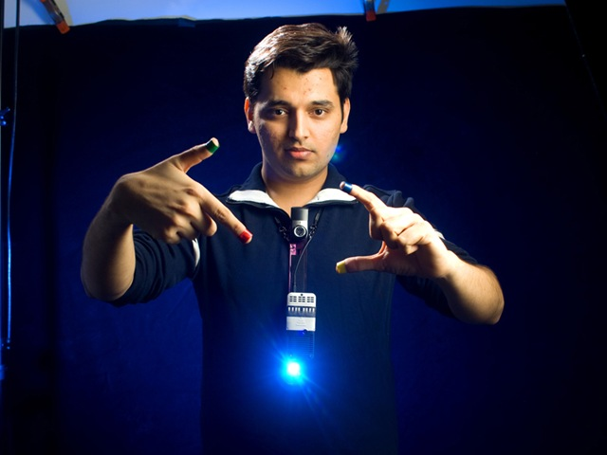

Michael Plasmeier

When you pull a book off of the shelf of a bookstore, you want to know what other people thought of the book. Right now, you can pull out your cell phone and search the title of the book. Perhaps, with some of the newest cell phones, you could take a picture of the barcode. What if, when you picked up a book, the rating from Amazon.com would appear on the book’s cover?
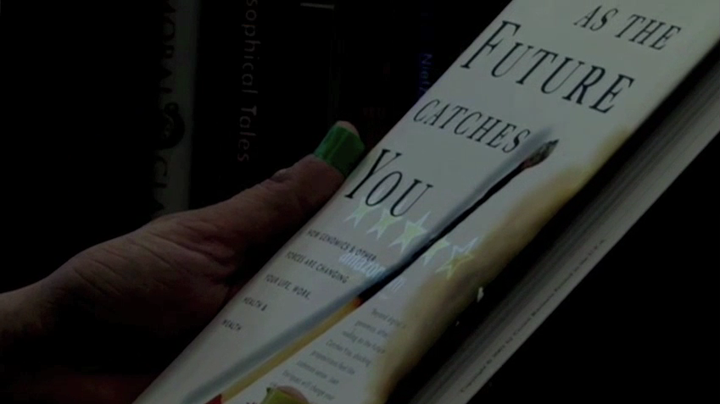
Panav Mistry, a graduate student in the MIT Media Lab’s Fluid Interfaces group, has done this. The Fluid Interfaces group, run by Associate Professor Pattie Maes, seeks to integrate digital information into our daily lives beyond the traditional interfaces.
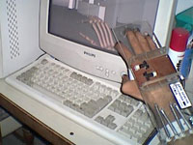
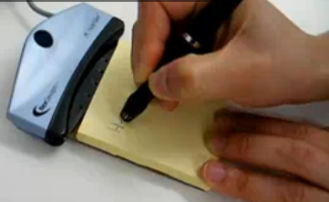
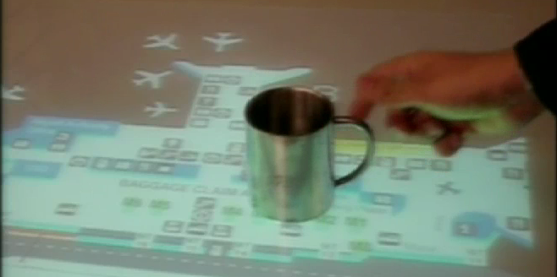
Mistry started out trying to bring the real and digital worlds together on his own in 2000 when he disassembled old fashioned mice, the kind with balls in them. He hooked up the encoders that read the ball’s position to strings which he attached to his hand. As he moved his fingers up and down, the system was able to read the position of each finger and display the result on a computer. Later he became a student in MIT’s Media Lab. In 2008, he made Quickies, which created digital sticky notes as he wrote on actual sticky notes. The system also parsed the sticky note as he wrote and presented relevant information on his computer screen. It could also take relevant actions such as scheduling a meeting in his Exchange calendar when he wrote a note about the meeting on a sticky note. Another one of his projects modeled an airport map. As he put objects on the table, the map would respond. When a boarding pass was placed on the table it would show the user how to get to the gate. When a coffee cup was placed on the table, the table would provide directions to find more coffee. He had brought objects into the computer world.
But in 2009, Mistry wanted to do the opposite. He wanted to bring the computer into the physical world. Instead of pointing at icons with a mouse, people would point at objects with their hands. Instead of learning an interface developed thirty or more years ago for ease of implementation, people would just act naturally. Mistry’s project is called “SixthSense” and it consists of a camera, cell phone, and projector linked together. All of the components can be bought off the shelf; what Mistry did was put it all together and demonstrate some applications of the technology. The camera recognizes objects in the surrounding area and gestures which one makes. Currently, he uses a computer to process the images from the camera, but in the future a smaller device will be able to do that. He uses a cell phone to retrieve information over the cell network. Finally, a microprojector displays the information onto the object itself. For example with the book, the camera takes a picture of the book and the computer recognizes that it is a book. The cell phone then connects to Amazon and looks up the book’s reviews over the internet. The projector then displays the retrieved information directly onto a book. The information just appears, without one having to pull a device out of one’s pocket and without one having to fumble with a web browser. Besides the book reviews, the SixthSense device could display real time flight status on a ticket or evaluate paper towels for a set of criteria.
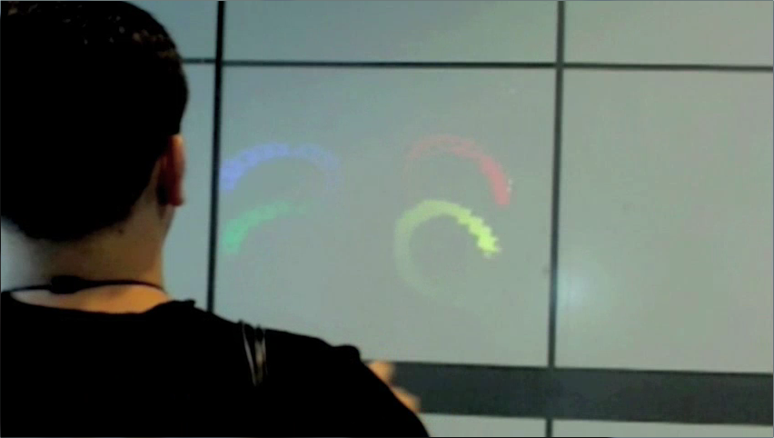
But the system is not limited to objects; the camera can also track fingers as they are waved through the air in front of the camera. Currently, the device requires that one wear special caps on one’s fingers, but future versions should be able to track fingers without this. A user wearing the SixthSense device can walk up to any wall and start “painting” on the wall using their fingers. The camera tracks each of the caps as the fingers move through space. The tracks are then projected onto the wall, like a projector displaying a PowerPoint. As soon as one steps away from the wall, the projector has nothing to project on to, and the painting naturally disappears. But the painting is not totally gone. It still exists in computer memory and now the painting can be emailed to anyone or posted on a social network.
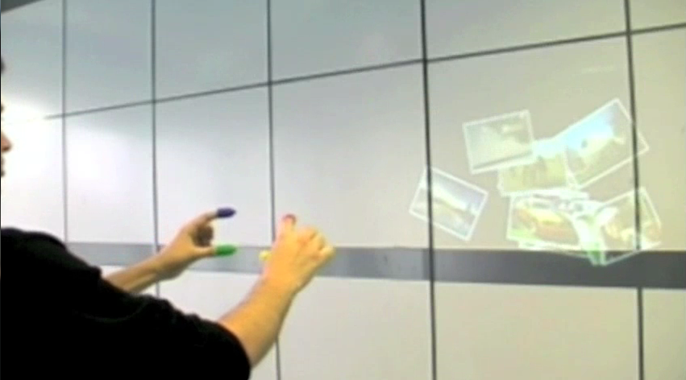
Even if you are not in front of a wall, the gesture interface of the SixthSense can be used to tell the device to take a picture. The wearer only needs to make his hands in the shape of a photo frame to tell the device to take a picture. When the camera recognizes the camera gesture, it is programmed to save the image. Later, the wearer can walk up to a wall and display the photos, again like a PowerPoint. Similar to other gesture interface, the wearer can browse through the photos by waving through them as though they were physical photos lying on a table. This is similar to painting, except now the computer moves around photos, instead of drawing lines. However, unlike any gesture interface in the labs, the wearer can take a step back and project a slide show to his friends.
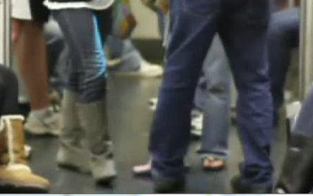
In fact, the collaborative aspects of the SixthSense may be its most appealing. Although many of the promotional materials from the Media Lab only show one person using the system, it is not ideal for this purpose. What you are looking at is broadcast for anyone to see. While you at least had some semblance of privacy on your screen, you are now literally projecting what you are doing to the world. In some cases this can be a positive. For example, you could play Ping-Pong on the floor of a subway car. The projector projects a moving ball, and the camera recognizes when people’s feet come in contact with the ball.
Mistry has been working on using a blank piece of paper with the device, which makes it work like an iPad. He took the microphone from the webcam out of the webcam and clipped it to the paper. The microphone detects the sound of the finger as it is dragged along the paper. This is needed because the camera cannot discern if the finger is hovering a few centimeters over a paper or touching it. Mistry demonstrated browsing a conventional website on a blank piece of paper. The projector projects the website onto the paper. When the microphone hears the paper being touched, the camera looks where the finger is. It then treats this as a click with a mouse and the system loads the clicked-on link just like a normal computer. The paper can also be tilted in order to control a game, such as a racing game. The camera can easily detect the orientation of the paper in front of it. However, the accuracy of the touch recognition is nowhere near as good as the iPad. SixthSense really works better augmenting other information. For example, SixthSense could display current information over a newspaper’s weather map, or project a video related to a news story on a blank spot in a newspaper.
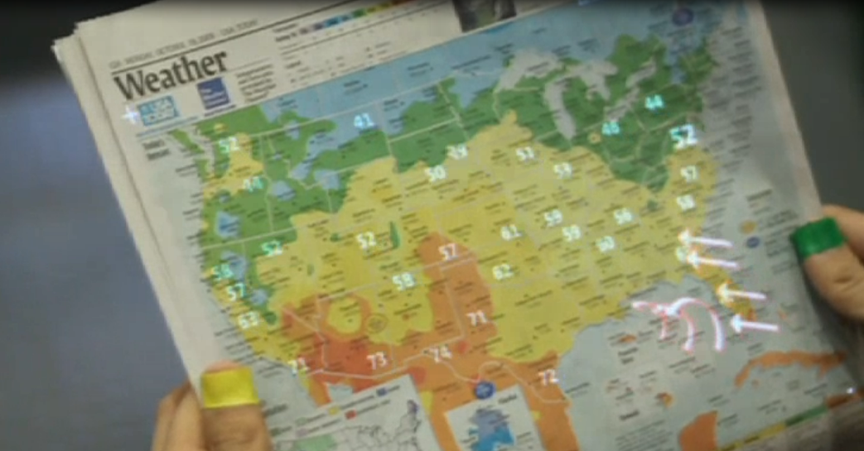
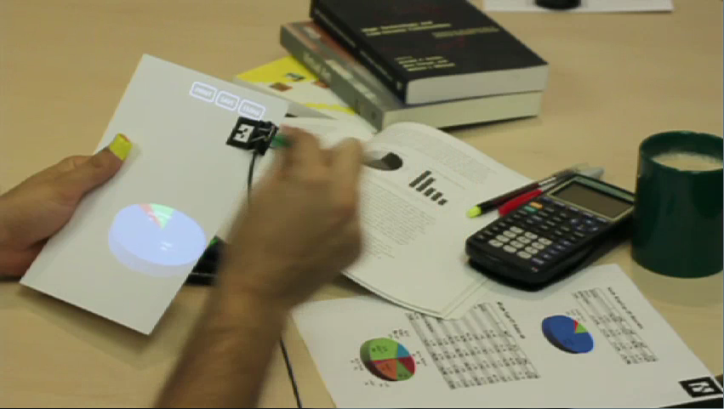
Where SixthSense really shines is when information is treated as objects on paper. One can point to a report with a graph, circle the graph, and then pull it to a blank sheet of paper. SixthSense projects the graph onto the paper so that one can use gestures to edit it. Next, one could print the page on a printer and make further changes to the document with a pen. The system recognizes the new text and it updates the digital file automatically.
If one wants to do more in-depth editing, one can pinch one’s fingers over the document and throw it onto a computer. The camera notices as one grabs the document and it tracks one’s hand as it moves to the computer screen. When one’s hand is over the screen, one can release the pinch gesture and the document then pops up on the computer. One’s fingers never pinch anything physical, but the computer interprets the movement as a gesture. This requires a lot of behind the scenes effort, but is very intuitive for the user.
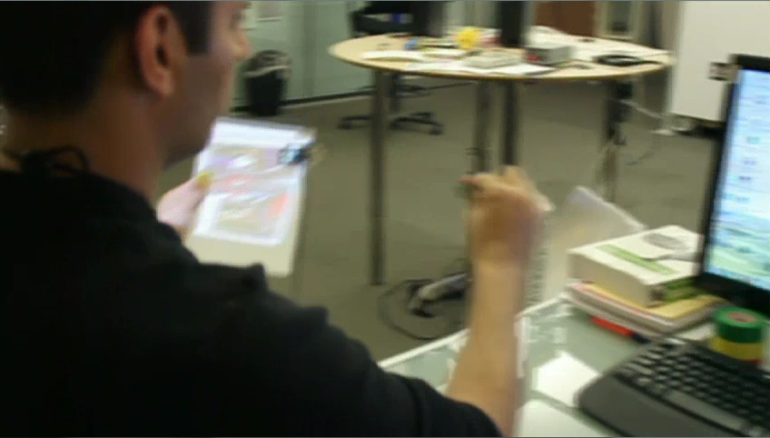
The device attracted glowing praise for it from top news agencies all over the world. Gizmodo called it a technology that may “change the way we look at the world forever.” Gizmodo said that SixthSense has the potential of “becoming the ultimate ‘transparent’ user interface for accessing information about everything around us.” David Pouge from the New York Times called it “a very cool idea.” Popular Scientist gave it a 2009 Invention award. CNET said the device could “trump Apple's multitouch.” The Sun in the United Kingdom compared the device to the movie Minority Report. Mistry was named a Technology Review “Young Inventor Under 35.”
The Lab’s sponsors are currently looking into making the product a reality. Samsung already makes microprojectors and mobile phones, so the hardware will not be challenging. Battery life for microprojectors may continue to be a problem. However, the real challenge of this device will be the software. I am sure that the demonstrations were carefully stage managed or “simulated.” There is a huge difference between getting something to work in the lab and getting it to robustly work in the real world. Each individual scenario must be programmed in individually. In addition, it assumes that many difficult problems in computer science have been solved. For example, SixthSense assumes that one can hold up the back of a roll of toilet paper and the system would be able to identify it. Even if one holds up the front cover of a book, the software is not completely reliable today. Book covers are far easier to recognize because there is a database of them; there is no database containing the various designs of the back sides of toilet paper packaging today. In addition, not a single cell phone supports printing today because an antiquated driver model bounds printing to existing operating systems. Getting printing to work from a cell phone would be really big news in itself. All these problems would have to be solved before SixthSense was ready for market.
In his videos, Mistry can reshoot a scene until the product works. He can carefully test his code to make sure that the device can demonstrate what the script calls for. In some cases, he can even simulate entire parts of the demo in order to demonstrate the potential applications. The demonstrations point out what could one day be possible, not necessarily what the device is doing. For example, because printing was not a central theme of the demo, Mistry most likely printed the document from a computer, not the device, as was implied in the video. In real life, none of this is possible. The device must work without a script and a second take.
Of course a cool demo does not translate exactly into a product that one would want to buy, even if the technology was robust enough. No one is going to walk around with a projector around their necks. However, some cell phones are starting to have projectors on them. Today it is mostly a gimmick, because the technology is unrefined and software has not been specially written to work with a projector. This used to be the case with touch screens. Early touch screens were inaccurate and many people questioned the accuracy of a touch keypad. Today, special software has been written for touchscreens, capable of more than was possible with a keypad. Today, almost every smartphone has a screen covering its entire face. Bits and pieces of this device will find themselves into the phones and devices of the future. Perhaps a future device will only have a camera component, without a projector. Or more immediately, the same image recognition algorithms could be used to look up product information on traditional cell phones for display on traditional screens.
In the long term, the Media Lab is also looking at using the device to restore a fifth sense to someone who lost one of their senses. In the case of a visually impaired person, the same visual recognition systems built to recognize a roll of toilet paper from any angle could help a visually impaired person hear what brand of toilet paper they were holding and the current price. Reusing commercial systems is wise. Mass market projects cost far less than those created specifically for disabled users and do far more.
SixthSense captured the attention of everyone who saw it. It is not right for every situation, so keyboards, mice and cell phones with screens are not going anywhere. But several years in the future, once the other problems in software are solved, SixthSense could bring the computer world to physical objects. Or maybe it will only incrementally improve our cell phones.

http://i.gizmodo.com/5167790/sixth-sense-technology-may-change-how-we-look-at-the-world-forever
http://pogue.blogs.nytimes.com/2009/02/11/at-ted-virtual-worlds-collide-with-reality/
http://www.popsci.com/scitech/article/2009-05/heightened-reality
http://news.cnet.com/8301-17938_105-10159601-1.html
http://www.thesun.co.uk/sol/homepage/news/article2224087.ece
http://www.technologyreview.com/TR35/Profile.aspx?Cand=T&TRID=816

