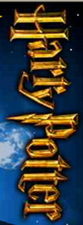
J.K. Rowiling
and the Order
of the Phoenix
Scholastic
5

