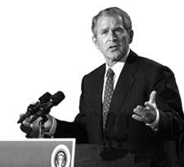

WMD
John Kerry
Vote!
This Oct. 21
For president
?????
?????

